#
# Troubled firmware version.
#
root@ds-devops-prod-mon-2:~# ethtool -i eno5 | grep -ie "firmware-version"
firmware-version: 14.26.1040 (HP_2690110034)
root@ds-devops-prod-mon-2:~# ethtool -i eno6 | grep -ie "firmware-version"
firmware-version: 14.26.1040 (HP_2690110034)
root@ds-devops-prod-mon-2:~#

Исправил глюки с сетевой картой
Mellanox Technologies MT27710 Family [ConnectX-4 Lx]
на сервере m1-soc-ls1.
Сменил версию firmware на ней.

#
# https://support.hpe.com/hpsc/swd/public/detail?swItemId=MTX_d0e63d0a446746b2bc8d096096#tab4
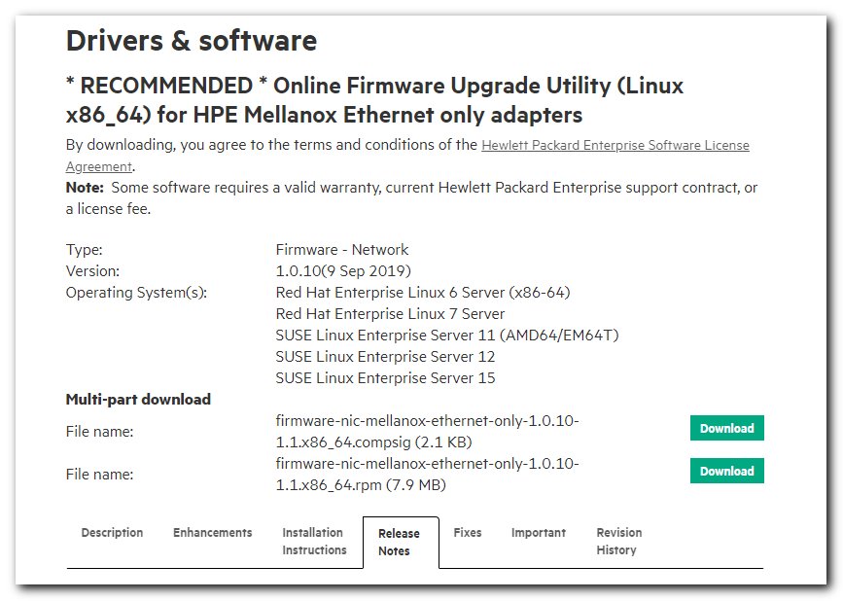
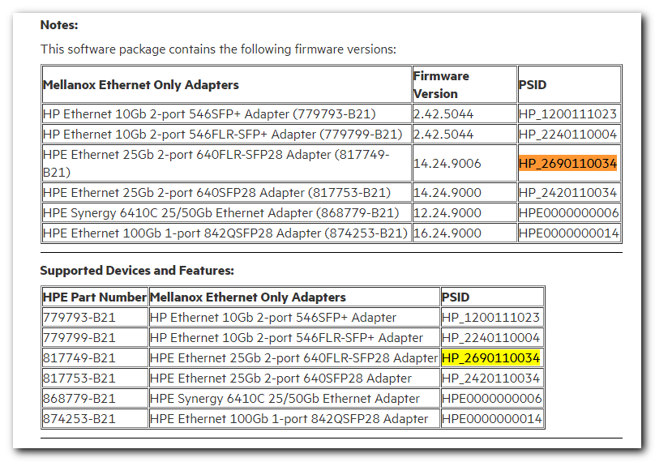

[s.belogrud@TCS4357]# scp /drives/c/Users/s.belogrud/Downloads/firmware-nic-mellanox-ethernet-only-1.0.10-1.1.x86_64.rpm root@m1-soc-ls1:/tmp/
firmware-nic-mellanox-ethernet-only-1.0.10-1.1.x86_64.rpm 100% 8042KB 15.1MB/s 00:00
[s.belogrud@TCS4357]#

[root@m1-soc-ls1 work]# mkdir 20200414-2043
[root@m1-soc-ls1 work]# cd 20200414-2043
[root@m1-soc-ls1 20200414-2043]# cp /tmp/firmware-nic-mellanox-ethernet-only-1.0.10-1.1.x86_64.rpm .

[root@m1-soc-ls1 20200414-2043]# rpm -ivh firmware-nic-mellanox-ethernet-only-1.0.10-1.1.x86_64.rpm
warning: firmware-nic-mellanox-ethernet-only-1.0.10-1.1.x86_64.rpm: Header V3 RSA/SHA256 Signature, key ID 26c2b797: NOKEY
Verifying... ################################# [100%]
Preparing... ################################# [100%]
Updating / installing...
1:firmware-nic-mellanox-ethernet-on################################# [100%]
[root@m1-soc-ls1 20200414-2043]#

[root@m1-soc-ls1 20200414-2043]# /usr/lib/x86_64-linux-gnu/firmware-nic-mellanox-ethernet-only-1.0.10-1.1/setup

##################################################################################################
HPE Mellanox InfiniBand Online Firmware Upgrade Utility for Linux
Copyright (c) 2011 Hewlett-Packard Enterprise Development Company, L.P.
##################################################################################################

SecureBoot is disabled.
List of Network Adapters detected on the Server.................
[0] 0000:12:00.0 Broadcom Inc. and subsidiaries
[1] 0000:5d:00.0 Mellanox Technologies

If PSID or FW_Version is not found for some interfaces, please check /tmp/datanjDv8b

Interface 0000:12:00.0 is not Mellanox one.

Mellanox card info for 0000:5d:00.0 = FW_VERSION 14.26.1040, BUS_INFO 0000:5d:00.0, PSID HP_2690110034
0000:5d:00.0
DEVICE INFO---------->15b3 1015 1590 d3
pciIdString-------------->15B3-1015-1590-00D3-HP_2690110034

Current Firmware Version is 14.26.1040 on 0000:5d:00.0
Repository has these firmware versions............[1] Image Version 14.24.9006
Repository doesn't have newer firmware version, Installed firmware version is the latest one..........Please Quit the updation.
Would you like to flash the firmware?
y/n/q (n):y

Current FW version on flash: 14.26.1040
New FW version: 14.24.9006

Note: The new FW version is older than the current FW version on flash.

Do you want to continue ? (y/n) [n] : y

Initializing image partition - OK
Writing Boot image component - OK
-I- To load new FW run mlxfwreset or reboot machine.
Firmware Flashed: SUCCESS for interface 0000:5d:00.0

Please Reboot node for new image to be loaded into silicon

[root@m1-soc-ls1 20200414-2043]#

#
# And then - reboot the server.
#

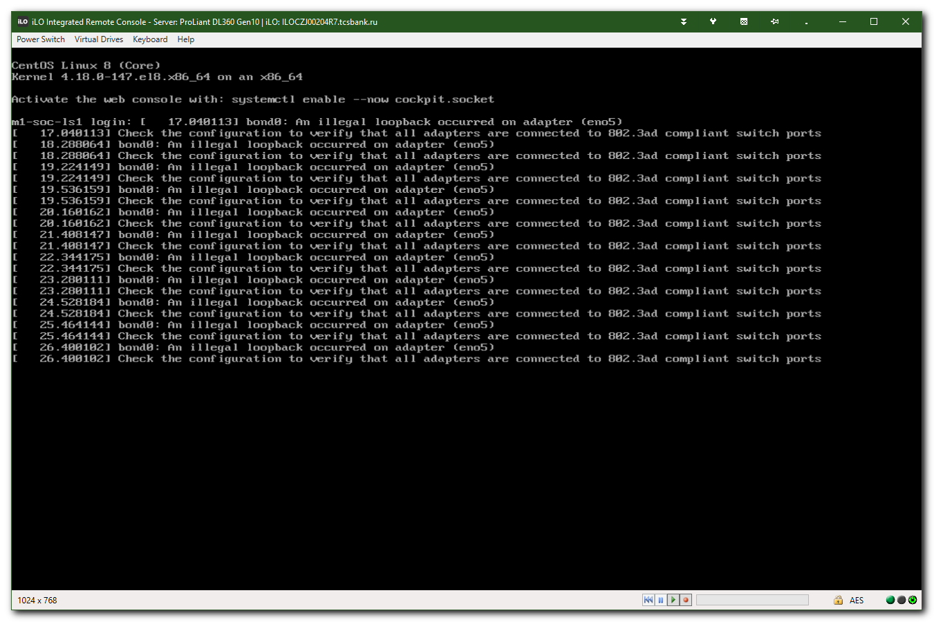

[root@m1-soc-ls1 ~]# dmidecode -t system
# dmidecode 3.2
Getting SMBIOS data from sysfs.
SMBIOS 3.2.1 present.
# SMBIOS implementations newer than version 3.2.0 are not
# fully supported by this version of dmidecode.

Handle 0x0089, DMI type 1, 27 bytes
System Information
Manufacturer: HPE
Product Name: ProLiant DL360 Gen10
Version: Not Specified
Serial Number: CZJ00204R7
UUID: 37393150-3636-5a43-4a30-303230345237
Wake-up Type: Power Switch
SKU Number: P19766-B21
Family: ProLiant

Handle 0x00AA, DMI type 32, 11 bytes
System Boot Information
Status: No errors detected

[root@m1-soc-ls1 ~]#

[root@m1-soc-ls1 ~]# tail -n 5 /var/log/messages
Apr 14 17:52:38 m1-soc-ls1 kernel: bond0: An illegal loopback occurred on adapter (eno5)#012Check the configuration to verify that all adapters are connected to 802.3ad compliant switch ports
Apr 14 17:52:39 m1-soc-ls1 kernel: bond0: An illegal loopback occurred on adapter (eno5)#012Check the configuration to verify that all adapters are connected to 802.3ad compliant switch ports
Apr 14 17:52:40 m1-soc-ls1 kernel: bond0: An illegal loopback occurred on adapter (eno5)#012Check the configuration to verify that all adapters are connected to 802.3ad compliant switch ports
Apr 14 17:52:41 m1-soc-ls1 kernel: bond0: An illegal loopback occurred on adapter (eno5)#012Check the configuration to verify that all adapters are connected to 802.3ad compliant switch ports
Apr 14 17:52:42 m1-soc-ls1 kernel: bond0: An illegal loopback occurred on adapter (eno5)#012Check the configuration to verify that all adapters are connected to 802.3ad compliant switch ports
[root@m1-soc-ls1 ~]#

# https://access.redhat.com/solutions/56604
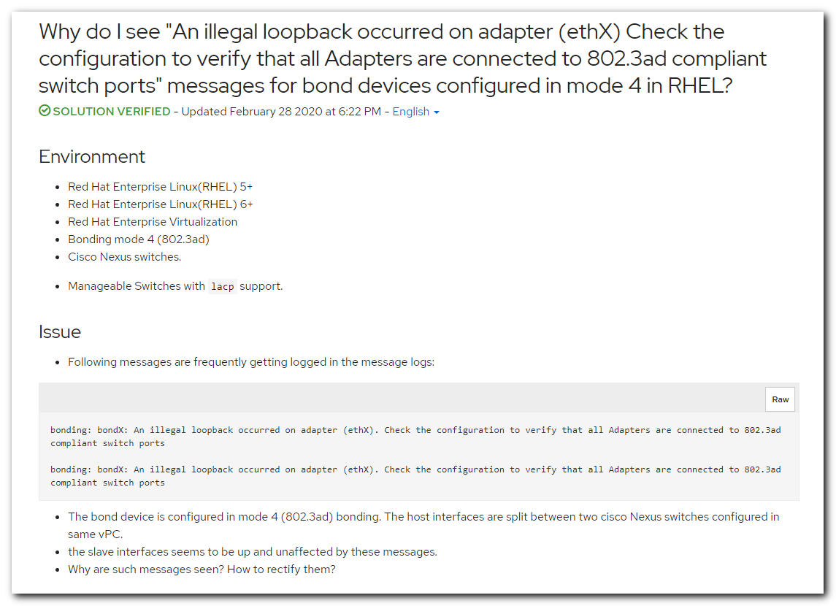
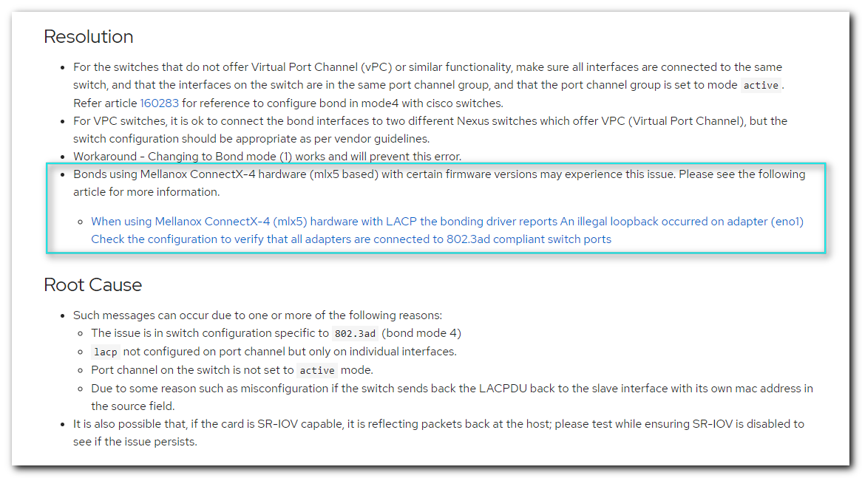

# https://access.redhat.com/solutions/4863081
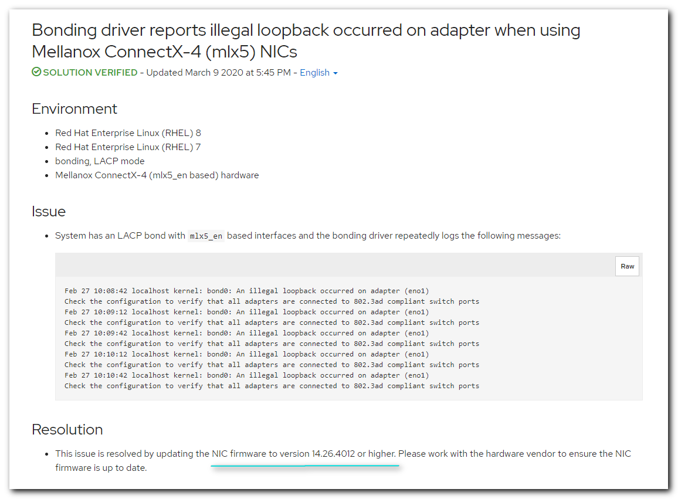

https://www.mellanox.com/support/firmware/hpe
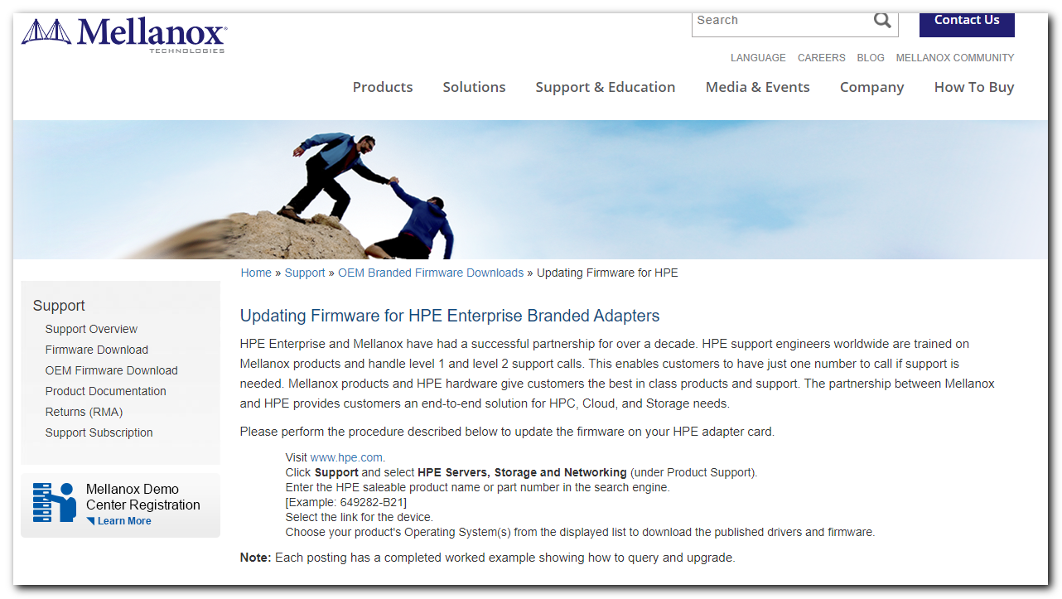

https://www.mellanox.com/support/firmware/identification
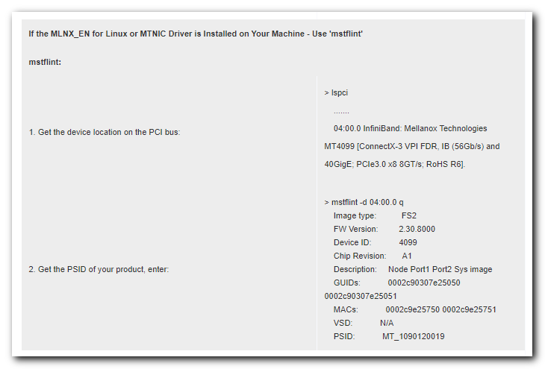
https://www.mellanox.com/support/firmware/firmware-downloads

https://www.mellanox.com/support/firmware/connectx4lxen
# Here I’ve no found PSID for our Mellanox network card (HP_2690110034). Only MT_...
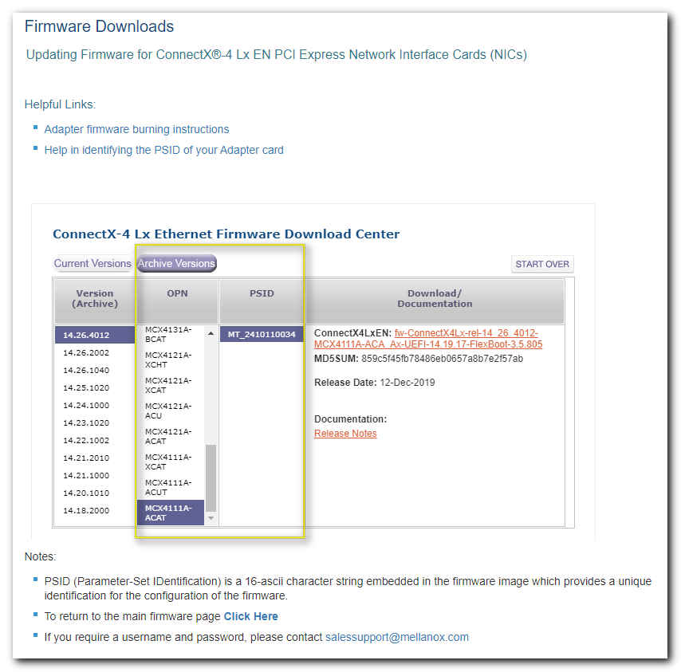

[root@m1-soc-ls1 ~]# ethtool -i eno5
driver: mlx5_core
version: 5.0-0
firmware-version: 14.26.1040 (HP_2690110034)
expansion-rom-version:
bus-info: 0000:5d:00.0
supports-statistics: yes
supports-test: yes
supports-eeprom-access: no
supports-register-dump: no
supports-priv-flags: yes
[root@m1-soc-ls1 ~]# lspci -s 0000:5d:00.0
5d:00.0 Ethernet controller: Mellanox Technologies MT27710 Family [ConnectX-4 Lx]
[root@m1-soc-ls1 ~]# lspci -s 0000:5d:00.1
5d:00.1 Ethernet controller: Mellanox Technologies MT27710 Family [ConnectX-4 Lx]
[root@m1-soc-ls1 ~]#

[root@m1-soc-ls1 ~]# ethtool eno5
Settings for eno5:
Supported ports: [ Backplane ]
Supported link modes: 1000baseKX/Full
10000baseKR/Full
25000baseCR/Full
25000baseKR/Full
25000baseSR/Full
Supported pause frame use: Symmetric
Supports auto-negotiation: Yes
Supported FEC modes: None BaseR
Advertised link modes: 1000baseKX/Full
10000baseKR/Full
25000baseCR/Full
25000baseKR/Full
25000baseSR/Full
Advertised pause frame use: Symmetric
Advertised auto-negotiation: Yes
Advertised FEC modes: None
Speed: 10000Mb/s
Duplex: Full
Port: Direct Attach Copper
PHYAD: 0
Transceiver: internal
Auto-negotiation: on
Supports Wake-on: g
Wake-on: g
Current message level: 0x00000004 (4)
link
Link detected: yes
[root@m1-soc-ls1 ~]# ethtool eno6
Settings for eno6:
Supported ports: [ FIBRE ]
Supported link modes: 1000baseKX/Full
10000baseKR/Full
25000baseCR/Full
25000baseKR/Full
25000baseSR/Full
Supported pause frame use: Symmetric
Supports auto-negotiation: Yes
Supported FEC modes: None BaseR
Advertised link modes: 1000baseKX/Full
10000baseKR/Full
25000baseCR/Full
25000baseKR/Full
25000baseSR/Full
Advertised pause frame use: Symmetric
Advertised auto-negotiation: Yes
Advertised FEC modes: None
Speed: 10000Mb/s
Duplex: Full
Port: FIBRE
PHYAD: 0
Transceiver: internal
Auto-negotiation: on
Supports Wake-on: g
Wake-on: d
Current message level: 0x00000004 (4)
link
Link detected: yes
[root@m1-soc-ls1 ~]#

[root@m1-soc-ls1 ~]# cat >> /etc/yum.repos.d/tcs-nexus-centos-8-base.repo
[tcs-nexus-centos-8-base]
name=Nexus - CentOS-8 - Base
baseurl=http://repo-linux.tcsbank.ru/repository/centos/centos/8/BaseOS/$basearch/os/
gpgcheck=1
gpgkey=file:///etc/pki/rpm-gpg/RPM-GPG-KEY-CentOS-8
skip_if_unavailable=True
proxy=_none_
[root@m1-soc-ls1 ~]# yum repolist
Nexus - CentOS-8 - Base 2.6 MB/s | 6.0 MB 00:02
Last metadata expiration check: 0:00:01 ago on Tue 14 Apr 2020 06:13:28 PM MSK.
Modular dependency problems:

Problem 1: conflicting requests
- nothing provides module(perl:5.26) needed by module perl-DBD-MySQL:4.046:8010020191114030811:073fa5fe-0.x86_64
Problem 2: conflicting requests
- nothing provides module(perl:5.26) needed by module perl-DBI:1.641:8010020191113222731:16b3ab4d-0.x86_64
repo id repo name status
tcs-nexus-centos-8-base Nexus - CentOS-8 - Base 2,233
[root@m1-soc-ls1 ~]#

[root@m1-soc-ls1 ~]# cat /etc/yum.repos.d/tcs-nexus-centos-8-centosplus.repo
[tcs-nexus-centos-8-centosplus]
name=Nexus - CentOS-$releasever - Plus
mirrorlist=http://repo-linux.tcsbank.ru/repository/centos/?release=$releasever&arch=$basearch&repo=centosplus&infra=$infra
#baseurl=http://mirror.centos.org/$contentdir/$releasever/centosplus/$basearch/os/
gpgcheck=1
enabled=0
gpgkey=file:///etc/pki/rpm-gpg/RPM-GPG-KEY-centosofficial
[root@m1-soc-ls1 ~]#

#
# Ansible doesn't work on just installed Centos 8.
#
(env) [support@centos msp-scm]$ ansible-playbook playbook-dco-bootstrap.yml -i list_of_hosts --become --extra-vars "ansible_user=root ansible_password=$(pass common/linux-default) ansible_sudo_pass=$(pass common/linux-default) ansible_ssh_common_args='-oStrictHostKeyChecking=no -oPubkeyAuthentication=no -oUserKnownHostsFile=/dev/null'"

PLAY [all[0]] *****************************************************************************************************************************************************************************************

TASK [assert] *****************************************************************************************************************************************************************************************
Tuesday 14 April 2020 18:07:40 +0300 (0:00:00.361) 0:00:00.361 *********
ok: [m1-soc-ls1.tcsbank.ru] => {
"changed": false
}

MSG:

All assertions passed

PLAY [all:!localhost] *********************************************************************************************************************************************************************************

TASK [Gathering Facts] ********************************************************************************************************************************************************************************
Tuesday 14 April 2020 18:07:40 +0300 (0:00:00.093) 0:00:00.455 *********
fatal: [m1-soc-ls1.tcsbank.ru]: FAILED! => {
"changed": false,
"rc": 127
}

MSG:

MODULE FAILURE
See stdout/stderr for the exact error

MODULE_STDOUT:

/bin/sh: /usr/bin/python: No such file or directory

MODULE_STDERR:

Shared connection to m1-soc-ls1.tcsbank.ru closed.

NO MORE HOSTS LEFT ************************************************************************************************************************************************************************************

NO MORE HOSTS LEFT ************************************************************************************************************************************************************************************

PLAY RECAP ********************************************************************************************************************************************************************************************
m1-soc-ls1.tcsbank.ru : ok=1 changed=0 unreachable=0 failed=1

Tuesday 14 April 2020 18:07:47 +0300 (0:00:06.743) 0:00:07.199 *********
===============================================================================
Gathering Facts -------------------------------------------------------------------------------------------------------------------------------------------------------------------------------- 6.74s
assert ----------------------------------------------------------------------------------------------------------------------------------------------------------------------------------------- 0.09s
(env) [support@centos msp-scm]$

#
# This is solution!!!
# https://www.toptechskills.com/ansible-tutorials-courses/how-to-fix-usr-bin-python-not-found-error-tutorial/
#

ln --symbolic /usr/bin/python3 /usr/bin/python

#
# But anyway for Centos 8 not prepaired appropriate repos in ansible playbook!
#
fatal: [m1-soc-ls1.tcsbank.ru]: FAILED! => {
"changed": false,
"rc": 1,
"results": []
}

MSG:

Failed to synchronize repodata: Failed to download metadata for repo 'CentOS-Base'

NO MORE HOSTS LEFT ************************************************************************************************************************************************************************************

NO MORE HOSTS LEFT ************************************************************************************************************************************************************************************

PLAY RECAP ********************************************************************************************************************************************************************************************
m1-soc-ls1.tcsbank.ru : ok=24 changed=8 unreachable=0 failed=1

[root@m1-soc-ls1 yum.repos.d]# cat tcs-nexus-epel.repo

[tcs-nexus-epel]
name=Nexus - Extra Packages for Enterprise Linux
baseurl=http://repo-linux.tcsbank.ru/repository/epel/$releasever/$basearch/
enabled=1
gpgcheck=0
repo_gpgcheck=0
skip_if_unavailable=True
proxy=_none_
[root@m1-soc-ls1 yum.repos.d]#

#
# Still unavailable to find package flint or msflint.
#

# https://centos.pkgs.org/8/centos-appstream-x86_64/mstflint-4.12.0-1.el8.x86_64.rpm.html

[s.belogrud@TCS4357]# wget http://mirror.centos.org/centos/8/AppStream/x86_64/os/Packages/mstflint-4.12.0-1.el8.x86_64.rpm
--2020-04-14 19:44:54-- http://mirror.centos.org/centos/8/AppStream/x86_64/os/Packages/mstflint-4.12.0-1.el8.x86_64.rpm
Resolving mirror.centos.org... 81.171.33.194
Connecting to mirror.centos.org|81.171.33.194|:80... connected.
HTTP request sent, awaiting response... 200 OK
Length: 3582276 (3.4M) [application/x-rpm]
Saving to: `mstflint-4.12.0-1.el8.x86_64.rpm'

100%[==========================================================================================================================================================>] 3,582,276 7.23M/s in 0.5s

2020-04-14 19:44:55 (7.23 MB/s) - `mstflint-4.12.0-1.el8.x86_64.rpm' saved [3582276/3582276]

[s.belogrud@TCS4357]# scp mstflint-4.12.0-1.el8.x86_64.rpm root@m1-soc-ls1:/tmp/
mstflint-4.12.0-1.el8.x86_64.rpm 100% 3498KB 16.1MB/s 00:00
[s.belogrud@TCS4357]#

[root@m1-soc-ls1 work]# yum localinstall 20200414-1941/mstflint-4.12.0-1.el8.x86_64.rpm
Last metadata expiration check: 0:08:05 ago on Tue 14 Apr 2020 07:38:50 PM MSK.
Modular dependency problems:

Problem 1: conflicting requests
- nothing provides module(perl:5.26) needed by module perl-DBD-MySQL:4.046:8010020191114030811:073fa5fe-0.x86_64
Problem 2: conflicting requests
- nothing provides module(perl:5.26) needed by module perl-DBI:1.641:8010020191113222731:16b3ab4d-0.x86_64
Error:
Problem: conflicting requests
- nothing provides libboost_regex.so.1.66.0()(64bit) needed by mstflint-4.12.0-1.el8.x86_64
(try to add '--skip-broken' to skip uninstallable packages or '--nobest' to use not only best candidate packages)
[root@m1-soc-ls1 work]#
[root@m1-soc-ls1 work]#

[root@m1-soc-ls1 work]# yum localinstall --skip-broken 20200414-1941/mstflint-4.12.0-1.el8.x86_64.rpm
Last metadata expiration check: 0:10:10 ago on Tue 14 Apr 2020 07:38:50 PM MSK.
Modular dependency problems:

Problem 1: conflicting requests
- nothing provides module(perl:5.26) needed by module perl-DBD-MySQL:4.046:8010020191114030811:073fa5fe-0.x86_64
Problem 2: conflicting requests
- nothing provides module(perl:5.26) needed by module perl-DBI:1.641:8010020191113222731:16b3ab4d-0.x86_64
Dependencies resolved.
Nothing to do.
Complete!
[root@m1-soc-ls1 work]#

[s.belogrud@TCS4357]# wget ftp://ftp.pbone.net/mirror/ftp.centos.org/8-stream/AppStream/x86_64/os/Packages/boost-regex-1.66.0-6.el8.x86_64.rpm
--2020-04-14 19:55:42-- ftp://ftp.pbone.net/mirror/ftp.centos.org/8-stream/AppStream/x86_64/os/Packages/boost-regex-1.66.0-6.el8.x86_64.rpm
=> `boost-regex-1.66.0-6.el8.x86_64.rpm'
Resolving ftp.pbone.net... 93.179.225.212
Connecting to ftp.pbone.net|93.179.225.212|:21... connected.
Logging in as anonymous ... Logged in!
==> SYST ... done. ==> PWD ... done.
==> TYPE I ... done. ==> CWD (1) /mirror/ftp.centos.org/8-stream/AppStream/x86_64/os/Packages ... done.
==> SIZE boost-regex-1.66.0-6.el8.x86_64.rpm ... 292624
==> PASV ... done. ==> RETR boost-regex-1.66.0-6.el8.x86_64.rpm ... done.
Length: 292624 (286K) (unauthoritative)

100%[==========================================================================================================================================================>] 292,624 689K/s in 0.4s

2020-04-14 19:55:44 (689 KB/s) - `boost-regex-1.66.0-6.el8.x86_64.rpm' saved [292624]

[s.belogrud@TCS4357]#

[s.belogrud@TCS4357]# scp boost-regex-1.66.0-6.el8.x86_64.rpm root@m1-soc-ls1:/tmp/
boost-regex-1.66.0-6.el8.x86_64.rpm 100% 286KB 14.8MB/s 00:00
[s.belogrud@TCS4357]#

[root@m1-soc-ls1 20200414-1941]# yum localinstall mstflint-4.12.0-1.el8.x86_64.rpm boost-regex-1.66.0-6.el8.x86_64.rpm
Last metadata expiration check: 0:17:22 ago on Tue 14 Apr 2020 07:38:50 PM MSK.
Modular dependency problems:

Problem 1: conflicting requests
- nothing provides module(perl:5.26) needed by module perl-DBD-MySQL:4.046:8010020191114030811:073fa5fe-0.x86_64
Problem 2: conflicting requests
- nothing provides module(perl:5.26) needed by module perl-DBI:1.641:8010020191113222731:16b3ab4d-0.x86_64
Dependencies resolved.
====================================================================================================================================================================================================
Package Architecture Version Repository Size
====================================================================================================================================================================================================
Installing:
mstflint x86_64 4.12.0-1.el8 @commandline 3.4 M
boost-regex x86_64 1.66.0-6.el8 @commandline 286 k

Transaction Summary
====================================================================================================================================================================================================
Install 2 Packages

Total size: 3.7 M
Installed size: 18 M
Is this ok [y/N]: y
Downloading Packages:
Running transaction check
Transaction check succeeded.
Running transaction test
Transaction test succeeded.
Running transaction
Preparing : 1/1
Installing : boost-regex-1.66.0-6.el8.x86_64 1/2
Running scriptlet: boost-regex-1.66.0-6.el8.x86_64 1/2
Installing : mstflint-4.12.0-1.el8.x86_64 2/2
Running scriptlet: mstflint-4.12.0-1.el8.x86_64 2/2
Verifying : mstflint-4.12.0-1.el8.x86_64 1/2
Verifying : boost-regex-1.66.0-6.el8.x86_64 2/2

Installed:
mstflint-4.12.0-1.el8.x86_64 boost-regex-1.66.0-6.el8.x86_64

Complete!
[root@m1-soc-ls1 20200414-1941]#

................................................................................

#
# https://www.mellanox.com/support/firmware/nic
#

[s.belogrud@TCS4357]# wget --no-check-certificate https://www.openfabrics.org/downloads/mstflint/mstflint-4.4.0.tar.gz
--2020-04-14 18:46:45-- https://www.openfabrics.org/downloads/mstflint/mstflint-4.4.0.tar.gz
Resolving www.openfabrics.org... 69.55.231.76
Connecting to www.openfabrics.org|69.55.231.76|:443... connected.
WARNING: cannot verify www.openfabrics.org's certificate, issued by `/C=RU/ST=Moscow/L=Moscow/O=Tinkoff Bank/CN=SI':
Unable to locally verify the issuer's authority.
HTTP request sent, awaiting response... 200 OK
Length: 1348758 (1.3M) [application/x-gzip]
Saving to: `mstflint-4.4.0.tar.gz'

100%[==========================================================================================================================================================>] 1,348,758 967K/s in 1.4s

2020-04-14 18:46:48 (967 KB/s) - `mstflint-4.4.0.tar.gz' saved [1348758/1348758]

[s.belogrud@TCS4357]#

[s.belogrud@TCS4357]# scp mstflint-4.4.0.tar.gz root@m1-soc-ls1:/tmp/
mstflint-4.4.0.tar.gz 100% 1317KB 15.8MB/s 00:00
[s.belogrud@TCS4357]#

[root@m1-soc-ls1 yum.repos.d]# mkdir -p ~/work/20200414-1848
[root@m1-soc-ls1 yum.repos.d]# cp /tmp/mstflint-4.4.0.tar.gz ~/work/20200414-1848/
[root@m1-soc-ls1 yum.repos.d]# cd ~/work/20200414-1848/
[root@m1-soc-ls1 20200414-1848]# gunzip mstflint-4.4.0.tar.gz
[root@m1-soc-ls1 20200414-1848]#

[root@m1-soc-ls1 20200414-1848]# tar -xf mstflint-4.4.0.tar
[root@m1-soc-ls1 20200414-1848]# ll
total 6376
drwxr-xr-x 23 3189 101 4096 May 24 2016 mstflint-4.4.0
-rw-r--r-- 1 root root 6522880 Apr 14 18:47 mstflint-4.4.0.tar
[root@m1-soc-ls1 20200414-1848]#

[root@m1-soc-ls1 mstflint-4.4.0]# ./configure --disable-dc --disable-inband

[root@m1-soc-ls1 mstflint-4.4.0]# yum install make
Nexus - Extra Packages for Enterprise Linux 353 kB/s | 2.0 kB 00:00
Failed to download metadata for repo 'tcs-nexus-epel'
Ignoring repositories: tcs-nexus-epel
Last metadata expiration check: 0:20:18 ago on Tue 14 Apr 2020 06:31:26 PM MSK.
Modular dependency problems:

Problem 1: conflicting requests
- nothing provides module(perl:5.26) needed by module perl-DBD-MySQL:4.046:8010020191114030811:073fa5fe-0.x86_64
Problem 2: conflicting requests
- nothing provides module(perl:5.26) needed by module perl-DBI:1.641:8010020191113222731:16b3ab4d-0.x86_64
Dependencies resolved.
====================================================================================================================================================================================================
Package Architecture Version Repository Size
====================================================================================================================================================================================================
Installing:
make x86_64 1:4.2.1-9.el8 tcs-nexus-centos-8-base 498 k

Transaction Summary
====================================================================================================================================================================================================
Install 1 Package

Total download size: 498 k
Installed size: 1.4 M
Is this ok [y/N]: y
Downloading Packages:
make-4.2.1-9.el8.x86_64.rpm 512 kB/s | 498 kB 00:00
----------------------------------------------------------------------------------------------------------------------------------------------------------------------------------------------------
Total 511 kB/s | 498 kB 00:00
warning: /var/cache/dnf/tcs-nexus-centos-8-base-1363f4b2d5422939/packages/make-4.2.1-9.el8.x86_64.rpm: Header V3 RSA/SHA256 Signature, key ID 8483c65d: NOKEY
Nexus - CentOS-8 - Base 0.0 B/s | 0 B 00:00
Curl error (37): Couldn't read a file:// file for file:///etc/pki/rpm-gpg/RPM-GPG-KEY-CentOS-8 [Couldn't open file /etc/pki/rpm-gpg/RPM-GPG-KEY-CentOS-8]
The downloaded packages were saved in cache until the next successful transaction.
You can remove cached packages by executing 'dnf clean packages'.
[root@m1-soc-ls1 mstflint-4.4.0]#

[root@m1-soc-ls1 mstflint-4.4.0]# dnf clean packages
2 files removed
[root@m1-soc-ls1 mstflint-4.4.0]#

#
# I've turned off gpgcheck.
#
[root@m1-soc-ls1 mstflint-4.4.0]# vim /etc/yum.repos.d/tcs-nexus-centos-8-base.repo
[root@m1-soc-ls1 mstflint-4.4.0]# yum install make
Nexus - CentOS-8 - Base 798 kB/s | 3.8 kB 00:00
Nexus - Extra Packages for Enterprise Linux 444 kB/s | 2.0 kB 00:00
Failed to download metadata for repo 'tcs-nexus-epel'
Ignoring repositories: tcs-nexus-epel
Modular dependency problems:

Problem 1: conflicting requests
- nothing provides module(perl:5.26) needed by module perl-DBD-MySQL:4.046:8010020191114030811:073fa5fe-0.x86_64
Problem 2: conflicting requests
- nothing provides module(perl:5.26) needed by module perl-DBI:1.641:8010020191113222731:16b3ab4d-0.x86_64
Dependencies resolved.
====================================================================================================================================================================================================
Package Architecture Version Repository Size
====================================================================================================================================================================================================
Installing:
make x86_64 1:4.2.1-9.el8 tcs-nexus-centos-8-base 498 k

Transaction Summary
====================================================================================================================================================================================================
Install 1 Package

Total size: 498 k
Installed size: 1.4 M
Is this ok [y/N]: y
Downloading Packages:
[SKIPPED] make-4.2.1-9.el8.x86_64.rpm: Already downloaded
Running transaction check
Transaction check succeeded.
Running transaction test
Transaction test succeeded.
Running transaction
Preparing : 1/1
Installing : make-1:4.2.1-9.el8.x86_64 1/1
Running scriptlet: make-1:4.2.1-9.el8.x86_64 1/1
Verifying : make-1:4.2.1-9.el8.x86_64 1/1

Installed:
make-1:4.2.1-9.el8.x86_64

Complete!
[root@m1-soc-ls1 mstflint-4.4.0]#

[root@m1-soc-ls1 mstflint-4.4.0]# make
make all-recursive
make[1]: Entering directory '/root/work/20200414-1848/mstflint-4.4.0'
Making all in common
make[2]: Entering directory '/root/work/20200414-1848/mstflint-4.4.0/common'
make[2]: Nothing to be done for 'all'.
make[2]: Leaving directory '/root/work/20200414-1848/mstflint-4.4.0/common'
Making all in mft_utils
make[2]: Entering directory '/root/work/20200414-1848/mstflint-4.4.0/mft_utils'
source='mft_sig_handler.c' object='mft_sig_handler.o' libtool=no \
DEPDIR=.deps depmode=none /bin/sh ../config/depcomp \
gcc -DHAVE_CONFIG_H -I. -I.. -I. -I../common -MD -pipe -Wall -W -Werror -g -O2 -Werror -DMST_UL -c mft_sig_handler.c
source='errmsg.cpp' object='errmsg.o' libtool=no \
DEPDIR=.deps depmode=none /bin/sh ../config/depcomp \
g++ -DHAVE_CONFIG_H -I. -I.. -I. -I../common -DHAVE_TERMIOS_H -Werror -DMST_UL -c -o errmsg.o errmsg.cpp
../config/depcomp: line 772: exec: g++: not found
make[2]: *** [Makefile:428: errmsg.o] Error 127
make[2]: Leaving directory '/root/work/20200414-1848/mstflint-4.4.0/mft_utils'
make[1]: *** [Makefile:508: all-recursive] Error 1
make[1]: Leaving directory '/root/work/20200414-1848/mstflint-4.4.0'
make: *** [Makefile:394: all] Error 2
[root@m1-soc-ls1 mstflint-4.4.0]#

[root@m1-soc-ls1 20200414-1941]# mstflint -d 0000:5d:00.0 q
Image type: FS3
FW Version: 14.26.1040
FW Release Date: 26.9.2019
Product Version: 14.26.1040
Rom Info: type=UEFI version=14.19.14 cpu=AMD64
type=PXE version=3.5.803 cpu=AMD64
Description: UID GuidsNumber
Base GUID: 9440c9ffff71e164 16
Base MAC: 9440c971e164 16
Image VSD: N/A
Device VSD: N/A
PSID: HP_2690110034
Security Attributes: N/A
[root@m1-soc-ls1 20200414-1941]# mstflint -d 0000:5d:00.1 q
Image type: FS3
FW Version: 14.26.1040
FW Release Date: 26.9.2019
Product Version: 14.26.1040
Rom Info: type=UEFI version=14.19.14 cpu=AMD64
type=PXE version=3.5.803 cpu=AMD64
Description: UID GuidsNumber
Base GUID: 9440c9ffff71e164 16
Base MAC: 9440c971e164 16
Image VSD: N/A
Device VSD: N/A
PSID: HP_2690110034
Security Attributes: N/A
[root@m1-soc-ls1 20200414-1941]#

................................................................................

#
# https://support.hpe.com/hpsc/swd/public/detail?swItemId=MTX_c93c3bae8f7c4b3a9c7b5e026b#tab3
#
[s.belogrud@TCS4357]# scp /drives/c/Users/s.belogrud/Downloads/firmware-* root@m1-soc-ls1:/tmp/
firmware-nic-mellanox-ethernet-only-1.0.11-1.1.x86_64.compsig 100% 2153 291.0KB/s 00:00
firmware-nic-mellanox-ethernet-only-1.0.11-1.1.x86_64.rpm 100% 7492KB 16.7MB/s 00:00
[s.belogrud@TCS4357]#

[root@m1-soc-ls1 20200414-2021]# rpm -qi firmware-nic-mellanox-ethernet-only-1.0.11-1.1.x86_64.rpm
warning: firmware-nic-mellanox-ethernet-only-1.0.11-1.1.x86_64.rpm: Header V3 RSA/SHA256 Signature, key ID 26c2b797: NOKEY
Name : firmware-nic-mellanox-ethernet-only
Version : 1.0.11
Release : 1.1
Architecture: x86_64
Install Date: (not installed)
Group : Applications/System
Size : 57598839
License : 2012 Hewlett Packard Enterprise Development LP
Signature : RSA/SHA256, Thu 31 Oct 2019 12:55:30 PM MSK, Key ID c208adde26c2b797
Source RPM : firmware-nic-mellanox-ethernet-only-1.0.11-1.1.src.rpm
Build Date : Thu 31 Oct 2019 12:35:05 PM MSK
Build Host : localhost
Relocations : (not relocatable)
Packager : Hewlett Packard Enterprise <Linux_SWdeliverables@groups.ext.hpe.com>
Vendor : Hewlett Packard Enterprise
URL : http://www.hpe.com/info/proliantlinux
Summary : Online Firmware Upgrade Utility (Linux x86_64) for HPE Mellanox Ethernet only adapters firmware
Description :
This package contains the Online Firmware Upgrade Utility (Linux x86_64) for HPE Mellanox Ethernet only adapters firmware
[root@m1-soc-ls1 20200414-2021]# rpm -ivh firmware-nic-mellanox-ethernet-only-1.0.11-1.1.x86_64.rpm
warning: firmware-nic-mellanox-ethernet-only-1.0.11-1.1.x86_64.rpm: Header V3 RSA/SHA256 Signature, key ID 26c2b797: NOKEY
Verifying... ################################# [100%]
Preparing... ################################# [100%]
Updating / installing...
1:firmware-nic-mellanox-ethernet-on################################# [100%]
[root@m1-soc-ls1 20200414-2021]#

[root@m1-soc-ls1 20200414-2021]# rpm -qpl firmware-nic-mellanox-ethernet-only-1.0.11-1.1.x86_64.rpm
warning: firmware-nic-mellanox-ethernet-only-1.0.11-1.1.x86_64.rpm: Header V3 RSA/SHA256 Signature, key ID 26c2b797: NOKEY
/usr/lib/x86_64-linux-gnu/firmware-nic-mellanox-ethernet-only-1.0.11-1.1
/usr/lib/x86_64-linux-gnu/firmware-nic-mellanox-ethernet-only-1.0.11-1.1/.cpq_package.inc
/usr/lib/x86_64-linux-gnu/firmware-nic-mellanox-ethernet-only-1.0.11-1.1/.setup
/usr/lib/x86_64-linux-gnu/firmware-nic-mellanox-ethernet-only-1.0.11-1.1/CP040051.xml
/usr/lib/x86_64-linux-gnu/firmware-nic-mellanox-ethernet-only-1.0.11-1.1/getmlnxinfo
/usr/lib/x86_64-linux-gnu/firmware-nic-mellanox-ethernet-only-1.0.11-1.1/hpsetup
/usr/lib/x86_64-linux-gnu/firmware-nic-mellanox-ethernet-only-1.0.11-1.1/nic_fw
/usr/lib/x86_64-linux-gnu/firmware-nic-mellanox-ethernet-only-1.0.11-1.1/nic_fw/NICFWData.xml
/usr/lib/x86_64-linux-gnu/firmware-nic-mellanox-ethernet-only-1.0.11-1.1/nic_fw/fw-ConnectX3Pro-full-rel-2_42_5044-779793-B21_0A-CLP-8025-UEFI-14.11.48-FlexBoot-3.4.754.bin
/usr/lib/x86_64-linux-gnu/firmware-nic-mellanox-ethernet-only-1.0.11-1.1/nic_fw/fw-ConnectX3Pro-full-rel-2_42_5044-779799-B21_Ax-CLP-8025-UEFI-14.11.48-FlexBoot-3.4.754.bin
/usr/lib/x86_64-linux-gnu/firmware-nic-mellanox-ethernet-only-1.0.11-1.1/nic_fw/fw-ConnectX4Lx-rel-14_26_1040-817749-B21_Ax-UEFI-14.19.14-FlexBoot-3.5.803.bin
/usr/lib/x86_64-linux-gnu/firmware-nic-mellanox-ethernet-only-1.0.11-1.1/nic_fw/fw-ConnectX4Lx-rel-14_26_1040-817753-B21_Ax-UEFI-14.19.14-FlexBoot-3.5.803.bin
/usr/lib/x86_64-linux-gnu/firmware-nic-mellanox-ethernet-only-1.0.11-1.1/nic_fw/fw-ConnectX5-rel-16_26_1040-874253-B21_Ax-UEFI-14.19.14-FlexBoot-3.5.803.signed.bin
/usr/lib/x86_64-linux-gnu/firmware-nic-mellanox-ethernet-only-1.0.11-1.1/nic_fw/mstflint
/usr/lib/x86_64-linux-gnu/firmware-nic-mellanox-ethernet-only-1.0.11-1.1/payload.json
/usr/lib/x86_64-linux-gnu/firmware-nic-mellanox-ethernet-only-1.0.11-1.1/setup
/usr/lib/x86_64-linux-gnu/hp-scexe-compat
/usr/lib/x86_64-linux-gnu/hp-scexe-compat/CP040051.scexe
/usr/lib/x86_64-linux-gnu/scexe-compat
/usr/lib/x86_64-linux-gnu/scexe-compat/CP040051.scexe
[root@m1-soc-ls1 20200414-2021]#

[root@m1-soc-ls1 20200414-2021]# /usr/lib/x86_64-linux-gnu/firmware-nic-mellanox-ethernet-only-1.0.11-1.1/setup

##################################################################################################
HPE Mellanox InfiniBand Online Firmware Upgrade Utility for Linux
Copyright (c) 2011 Hewlett-Packard Enterprise Development Company, L.P.
##################################################################################################

SecureBoot is disabled.
List of Network Adapters detected on the Server.................
[0] 0000:12:00.0 Broadcom Inc. and subsidiaries
[1] 0000:5d:00.0 Mellanox Technologies

If PSID or FW_Version is not found for some interfaces, please check /tmp/datazL530h

Interface 0000:12:00.0 is not Mellanox one.

Mellanox card info for 0000:5d:00.0 = FW_VERSION 14.26.1040, BUS_INFO 0000:5d:00.0, PSID HP_2690110034
0000:5d:00.0
DEVICE INFO---------->15b3 1015 1590 d3
pciIdString-------------->15B3-1015-1590-00D3-HP_2690110034

Current Firmware Version is 14.26.1040 on 0000:5d:00.0
Repository has these firmware versions............[1] Image Version 14.26.1040
Repository doesn't have newer firmware version, Installed firmware version is the latest one..........Please Quit the updation.
Would you like to flash the firmware?
y/n/q (n):y

Current FW version on flash: 14.26.1040
New FW version: 14.26.1040

Note: The new FW version is the same as the current FW version on flash.

Do you want to continue ? (y/n) [n] : y

Initializing image partition - OK
Writing Boot image component - OK
-I- To load new FW run mstfwreset or reboot machine.
Firmware Flashed: SUCCESS for interface 0000:5d:00.0

Please Reboot node for new image to be loaded into silicon

[root@m1-soc-ls1 20200414-2021]#

#
# There is no results.
# Shit continue drops.
#

#
# On this server no problem with Mellanox card.
# Version firmware is 14.24.9006

[root@ds-soc-ls1 ~]# ethtool -i eno5
driver: mlx5_core
version: 5.0-0
firmware-version: 14.24.9006 (HP_2690110034)
expansion-rom-version:
bus-info: 0000:5d:00.0
supports-statistics: yes
supports-test: yes
supports-eeprom-access: no
supports-register-dump: no
supports-priv-flags: yes
[root@ds-soc-ls1 ~]# lspci -s 0000:5d:00.0
5d:00.0 Ethernet controller: Mellanox Technologies MT27710 Family [ConnectX-4 Lx]
[root@ds-soc-ls1 ~]#

#
# https://support.hpe.com/hpsc/swd/public/detail?swItemId=MTX_d0e63d0a446746b2bc8d096096#tab4
#

[s.belogrud@TCS4357]# scp /drives/c/Users/s.belogrud/Downloads/firmware-nic-mellanox-ethernet-only-1.0.10-1.1.x86_64.rpm root@m1-soc-ls1:/tmp/
firmware-nic-mellanox-ethernet-only-1.0.10-1.1.x86_64.rpm 100% 8042KB 15.1MB/s 00:00
[s.belogrud@TCS4357]#

[root@m1-soc-ls1 work]# mkdir 20200414-2043
[root@m1-soc-ls1 work]# cd 20200414-2043
[root@m1-soc-ls1 20200414-2043]# cp /tmp/firmware-nic-mellanox-ethernet-only-1.0.10-1.1.x86_64.rpm .
[root@m1-soc-ls1 20200414-2043]# rpm -ivh firmware-nic-mellanox-ethernet-only-1.0.10-1.1.x86_64.rpm
warning: firmware-nic-mellanox-ethernet-only-1.0.10-1.1.x86_64.rpm: Header V3 RSA/SHA256 Signature, key ID 26c2b797: NOKEY
Verifying... ################################# [100%]
Preparing... ################################# [100%]
package firmware-nic-mellanox-ethernet-only-1.0.11-1.1.x86_64 (which is newer than firmware-nic-mellanox-ethernet-only-1.0.10-1.1.x86_64) is already installed
[root@m1-soc-ls1 20200414-2043]# rpm -qpl firmware-nic-mellanox-ethernet-only-1.0.10-1.1.x86_64.rpm
warning: firmware-nic-mellanox-ethernet-only-1.0.10-1.1.x86_64.rpm: Header V3 RSA/SHA256 Signature, key ID 26c2b797: NOKEY
/usr/lib/x86_64-linux-gnu/firmware-nic-mellanox-ethernet-only-1.0.10-1.1
/usr/lib/x86_64-linux-gnu/firmware-nic-mellanox-ethernet-only-1.0.10-1.1/.cpq_package.inc
/usr/lib/x86_64-linux-gnu/firmware-nic-mellanox-ethernet-only-1.0.10-1.1/.setup
/usr/lib/x86_64-linux-gnu/firmware-nic-mellanox-ethernet-only-1.0.10-1.1/CP038539.xml
/usr/lib/x86_64-linux-gnu/firmware-nic-mellanox-ethernet-only-1.0.10-1.1/getmlnxinfo
/usr/lib/x86_64-linux-gnu/firmware-nic-mellanox-ethernet-only-1.0.10-1.1/hpsetup
/usr/lib/x86_64-linux-gnu/firmware-nic-mellanox-ethernet-only-1.0.10-1.1/nic_fw
/usr/lib/x86_64-linux-gnu/firmware-nic-mellanox-ethernet-only-1.0.10-1.1/nic_fw/NICFWData.xml
/usr/lib/x86_64-linux-gnu/firmware-nic-mellanox-ethernet-only-1.0.10-1.1/nic_fw/fw-ConnectX3Pro-full-rel-2_42_5044-779793-B21_0A-CLP-8025-UEFI-14.11.48-FlexBoot-3.4.754.bin
/usr/lib/x86_64-linux-gnu/firmware-nic-mellanox-ethernet-only-1.0.10-1.1/nic_fw/fw-ConnectX3Pro-full-rel-2_42_5044-779799-B21_Ax-CLP-8025-UEFI-14.11.48-FlexBoot-3.4.754.bin
/usr/lib/x86_64-linux-gnu/firmware-nic-mellanox-ethernet-only-1.0.10-1.1/nic_fw/fw-ConnectX4-rel-12_24_9000-868779-B21_Ax-UEFI-14.17.13-FlexBoot-3.5.603.signed.bin
/usr/lib/x86_64-linux-gnu/firmware-nic-mellanox-ethernet-only-1.0.10-1.1/nic_fw/fw-ConnectX4Lx-rel-14_24_9000-817753-B21_Ax-UEFI-14.17.13-FlexBoot-3.5.603.bin
/usr/lib/x86_64-linux-gnu/firmware-nic-mellanox-ethernet-only-1.0.10-1.1/nic_fw/fw-ConnectX4Lx-rel-14_24_9006-817749-B21_Ax-UEFI-14.17.13-FlexBoot-3.5.603.bin
/usr/lib/x86_64-linux-gnu/firmware-nic-mellanox-ethernet-only-1.0.10-1.1/nic_fw/fw-ConnectX5-rel-16_24_9000-874253-B21_Ax-UEFI-14.17.13-FlexBoot-3.5.603.signed.bin
/usr/lib/x86_64-linux-gnu/firmware-nic-mellanox-ethernet-only-1.0.10-1.1/nic_fw/mstflint
/usr/lib/x86_64-linux-gnu/firmware-nic-mellanox-ethernet-only-1.0.10-1.1/payload.json
/usr/lib/x86_64-linux-gnu/firmware-nic-mellanox-ethernet-only-1.0.10-1.1/setup
/usr/lib/x86_64-linux-gnu/hp-scexe-compat
/usr/lib/x86_64-linux-gnu/hp-scexe-compat/CP038539.scexe
/usr/lib/x86_64-linux-gnu/scexe-compat
/usr/lib/x86_64-linux-gnu/scexe-compat/CP038539.scexe
[root@m1-soc-ls1 20200414-2043]#

[root@m1-soc-ls1 20200414-2043]# yum remove firmware-nic-mellanox-ethernet-only-1.0.11-1.1.x86_64
Modular dependency problems:

Problem 1: conflicting requests
- nothing provides module(perl:5.26) needed by module perl-DBD-MySQL:4.046:8010020191114030811:073fa5fe-0.x86_64
Problem 2: conflicting requests
- nothing provides module(perl:5.26) needed by module perl-DBI:1.641:8010020191113222731:16b3ab4d-0.x86_64
Dependencies resolved.
====================================================================================================================================================================================================
Package Architecture Version Repository Size
====================================================================================================================================================================================================
Removing:
firmware-nic-mellanox-ethernet-only x86_64 1.0.11-1.1 @System 55 M

Transaction Summary
====================================================================================================================================================================================================
Remove 1 Package

Freed space: 55 M
Is this ok [y/N]: y
Running transaction check
Transaction check succeeded.
Running transaction test
Transaction test succeeded.
Running transaction
Preparing : 1/1
Erasing : firmware-nic-mellanox-ethernet-only-1.0.11-1.1.x86_64 1/1
Running scriptlet: firmware-nic-mellanox-ethernet-only-1.0.11-1.1.x86_64 1/1
Verifying : firmware-nic-mellanox-ethernet-only-1.0.11-1.1.x86_64 1/1

Removed:
firmware-nic-mellanox-ethernet-only-1.0.11-1.1.x86_64

Complete!
[root@m1-soc-ls1 20200414-2043]#

[root@m1-soc-ls1 20200414-2043]# rpm -ivh firmware-nic-mellanox-ethernet-only-1.0.10-1.1.x86_64.rpm
warning: firmware-nic-mellanox-ethernet-only-1.0.10-1.1.x86_64.rpm: Header V3 RSA/SHA256 Signature, key ID 26c2b797: NOKEY
Verifying... ################################# [100%]
Preparing... ################################# [100%]
Updating / installing...
1:firmware-nic-mellanox-ethernet-on################################# [100%]
[root@m1-soc-ls1 20200414-2043]#

[root@m1-soc-ls1 20200414-2043]# /usr/lib/x86_64-linux-gnu/firmware-nic-mellanox-ethernet-only-1.0.10-1.1/setup

##################################################################################################
HPE Mellanox InfiniBand Online Firmware Upgrade Utility for Linux
Copyright (c) 2011 Hewlett-Packard Enterprise Development Company, L.P.
##################################################################################################

SecureBoot is disabled.
List of Network Adapters detected on the Server.................
[0] 0000:12:00.0 Broadcom Inc. and subsidiaries
[1] 0000:5d:00.0 Mellanox Technologies

If PSID or FW_Version is not found for some interfaces, please check /tmp/datanjDv8b

Interface 0000:12:00.0 is not Mellanox one.

Mellanox card info for 0000:5d:00.0 = FW_VERSION 14.26.1040, BUS_INFO 0000:5d:00.0, PSID HP_2690110034
0000:5d:00.0
DEVICE INFO---------->15b3 1015 1590 d3
pciIdString-------------->15B3-1015-1590-00D3-HP_2690110034

Current Firmware Version is 14.26.1040 on 0000:5d:00.0
Repository has these firmware versions............[1] Image Version 14.24.9006
Repository doesn't have newer firmware version, Installed firmware version is the latest one..........Please Quit the updation.
Would you like to flash the firmware?
y/n/q (n):y

Current FW version on flash: 14.26.1040
New FW version: 14.24.9006

Note: The new FW version is older than the current FW version on flash.

Do you want to continue ? (y/n) [n] : y

Initializing image partition - OK
Writing Boot image component - OK
-I- To load new FW run mlxfwreset or reboot machine.
Firmware Flashed: SUCCESS for interface 0000:5d:00.0

Please Reboot node for new image to be loaded into silicon

[root@m1-soc-ls1 20200414-2043]#

................................................................................

#
# 20200525
# Here is not tested idea to apply firmware update on non Rhel systems. On Ubuntu, for example.
#
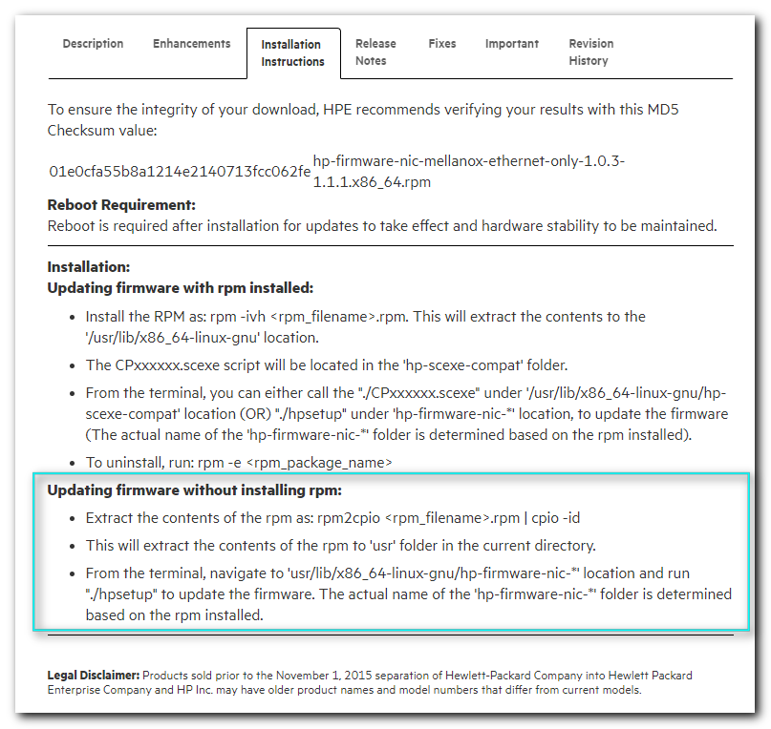

#
# Idea is extract firmware and utility from rpm to files. Compress them to tgz..
# Copy extracted archive to target server.
# Extract archive and run update utility.
# It was not tested, yet. I’ve asked Ivanaev Artyom to downgrade firmware with special HP web-service that controls firmware on modern HP servers.
#
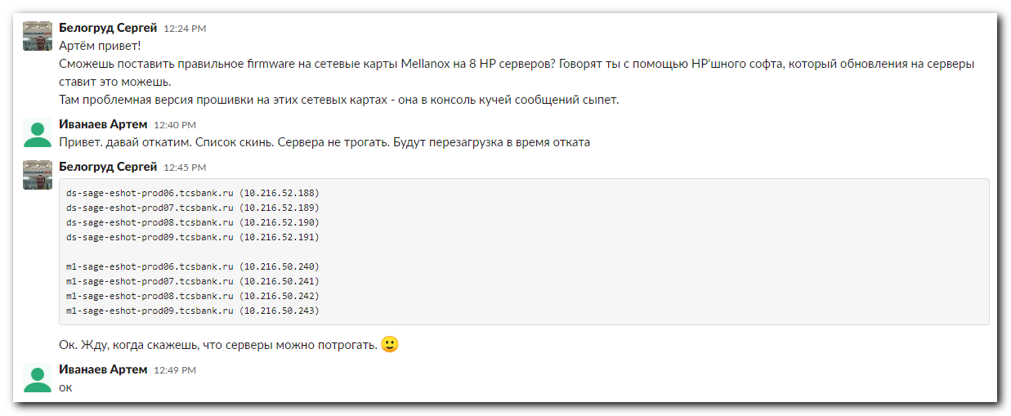

[s.belogrud@TCS4357]# scp /drives/c/Users/s.belogrud/Downloads/firmware-nic-mellanox-ethernet-only-1.0.10-1.1.x86_64.rpm bsv@m1-soc-ls1:/tmp/
firmware-nic-mellanox-ethernet-only-1.0.10-1.1.x86_64.rpm 100% 8042KB 27.2MB/s 00:00
[s.belogrud@TCS4357]#

[root@m1-soc-ls1 ~]# mkdir ~/work/20200525-1240
[root@m1-soc-ls1 ~]# cp /tmp/firmware-nic-mellanox-ethernet-only-1.0.10-1.1.x86_64.rpm ~/work/20200525-1240/
[root@m1-soc-ls1 ~]# cd ~/work/20200525-1240/
[root@m1-soc-ls1 20200525-1240]#

[root@m1-soc-ls1 20200525-1240]# rpm2cpio firmware-nic-mellanox-ethernet-only-1.0.10-1.1.x86_64.rpm | cpio -id
138327 blocks
[root@m1-soc-ls1 20200525-1240]# ll
total 8048
-rwx------. 1 root root 8235307 May 25 12:40 firmware-nic-mellanox-ethernet-only-1.0.10-1.1.x86_64.rpm
drwxr-xr-x. 3 root root 4096 May 25 12:42 usr
[root@m1-soc-ls1 20200525-1240]#

[root@m1-soc-ls1 20200525-1240]# tar cvzf firmware-nic-mellanox-ethernet-only-1.0.10-1.1.x86_64.tgz usr/
[root@m1-soc-ls1 20200525-1240]# cp firmware-nic-mellanox-ethernet-only-1.0.10-1.1.x86_64.tgz /tmp

[s.belogrud@TCS4357]# scp bsv@m1-soc-ls1:/tmp/firmware-nic-mellanox-ethernet-only-1.0.10-1.1.x86_64.tgz /drives/c/Users/s.belogrud/Downloads/
firmware-nic-mellanox-ethernet-only-1.0.10-1.1.x86_64.tgz 100% 9662KB 126.4KB/s 01:16
[s.belogrud@TCS4357]#

#
# 20210907
# Another task with this trouble.

*. Задача SD "На сервере ds-pr-paym-es-w-metal-01 моргает bond интерфейс" (https://forge.tcsbank.ru/case/5961850/info)("other20210901 SD#5961850 Network interface bond0 produce messages in log on server ds-pr-paym-es-w-metal-01").
Создал канал в Слаке #sd5961850 для коммуникации по задаче.

https://forge.tcsbank.ru/case/5961850/info
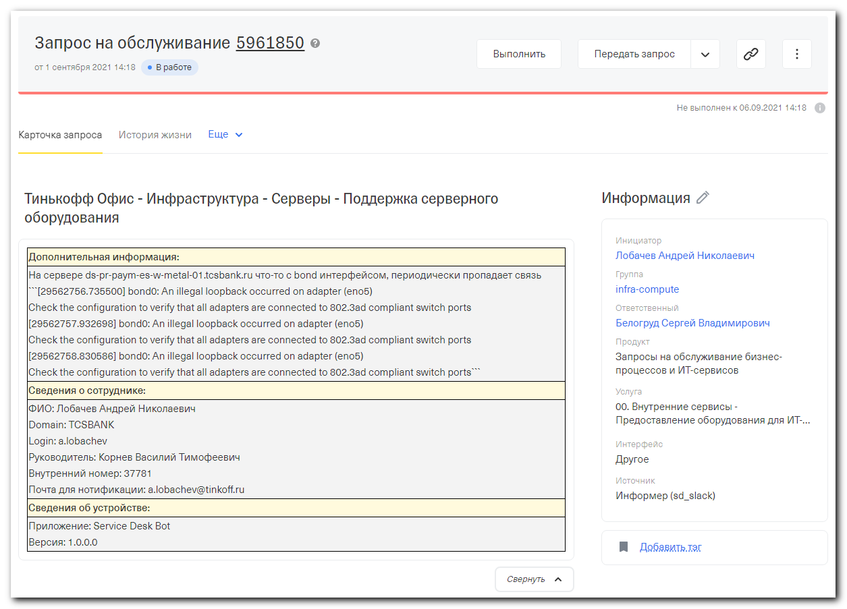
................................................................................
https://forge.tcsbank.ru/case/5961850/info

Дополнительная информация:
На сервере ds-pr-paym-es-w-metal-01.tcsbank.ru что-то с bond интерфейсом, периодически пропадает связь ```[29562756.735500] bond0: An illegal loopback occurred on adapter (eno5)
Check the configuration to verify that all adapters are connected to 802.3ad compliant switch ports
[29562757.932698] bond0: An illegal loopback occurred on adapter (eno5)
Check the configuration to verify that all adapters are connected to 802.3ad compliant switch ports
[29562758.830586] bond0: An illegal loopback occurred on adapter (eno5)
Check the configuration to verify that all adapters are connected to 802.3ad compliant switch ports```
Сведения о сотруднике:
ФИО: Лобачев Андрей Николаевич
Domain: TCSBANK
Login: a.lobachev
Руководитель: Корнев Василий Тимофеевич
Внутренний номер: 37781
Почта для нотификации: a.lobachev@tinkoff.ru

................................................................................

root@ds-pr-paym-es-w-metal-01 ~$ cat /etc/redhat-release
CentOS Linux release 7.8.2003 (Core)
root@ds-pr-paym-es-w-metal-01 ~$ cat /proc/net/bonding/bond0
Ethernet Channel Bonding Driver: v3.7.1 (April 27, 2011)

Bonding Mode: IEEE 802.3ad Dynamic link aggregation
Transmit Hash Policy: layer3+4 (1)
MII Status: up
MII Polling Interval (ms): 100
Up Delay (ms): 0
Down Delay (ms): 0

802.3ad info
LACP rate: fast
Min links: 0
Aggregator selection policy (ad_select): stable
System priority: 65535
System MAC address: 94:40:c9:86:da:30
Active Aggregator Info:
Aggregator ID: 7
Number of ports: 2
Actor Key: 21
Partner Key: 5
Partner Mac Address: 03:31:32:04:04:00

Slave Interface: eno5
MII Status: up
Speed: 25000 Mbps
Duplex: full
Link Failure Count: 2
Permanent HW addr: 94:40:c9:86:da:30
Slave queue ID: 0
Aggregator ID: 7
Actor Churn State: none
Partner Churn State: none
Actor Churned Count: 0
Partner Churned Count: 0
details actor lacp pdu:
system priority: 65535
system mac address: 94:40:c9:86:da:30
port key: 21
port priority: 255
port number: 1
port state: 63
details partner lacp pdu:
system priority: 127
system mac address: 03:31:32:04:04:00
oper key: 5
port priority: 127
port number: 4
port state: 63

Slave Interface: eno6
MII Status: up
Speed: 25000 Mbps
Duplex: full
Link Failure Count: 2
Permanent HW addr: 94:40:c9:86:da:31
Slave queue ID: 0
Aggregator ID: 7
Actor Churn State: none
Partner Churn State: none
Actor Churned Count: 0
Partner Churned Count: 0
details actor lacp pdu:
system priority: 65535
system mac address: 94:40:c9:86:da:30
port key: 21
port priority: 255
port number: 2
port state: 63
details partner lacp pdu:
system priority: 127
system mac address: 03:31:32:04:04:00
oper key: 5
port priority: 127
port number: 5
port state: 63
root@ds-pr-paym-es-w-metal-01 ~$

root@ds-pr-paym-es-w-metal-01 ~$ ip a | grep -w inet
inet 127.0.0.1/8 scope host lo
inet 169.254.0.1/16 brd 169.254.255.255 scope global docker0
inet 10.213.90.1/24 brd 10.213.90.255 scope global bond0.1390
root@ds-pr-paym-es-w-metal-01 ~$ ip route
default via 10.213.90.254 dev bond0.1390
10.213.90.0/24 dev bond0.1390 proto kernel scope link src 10.213.90.1
169.254.0.0/16 dev docker0 proto kernel scope link src 169.254.0.1
169.254.0.0/16 dev bond0 scope link metric 1009
169.254.0.0/16 dev bond0.1390 scope link metric 1014
root@ds-pr-paym-es-w-metal-01 ~$

................................................................................

root@ds-pr-paym-es-w-metal-01 ~$ ls -Alh /var/log/messages*
-rw------- 1 root root 68M Sep 1 17:20 /var/log/messages
-rw------- 1 root root 134M Aug 8 03:11 /var/log/messages-20210808
-rw------- 1 root root 134M Aug 15 03:34 /var/log/messages-20210815
-rw------- 1 root root 134M Aug 22 03:19 /var/log/messages-20210822
-rw------- 1 root root 135M Aug 29 03:43 /var/log/messages-20210829
root@ds-pr-paym-es-w-metal-01 ~$

root@ds-pr-paym-es-w-metal-01 ~$ grep -ie "bond" /var/log/messages-20210808 | head
Aug 1 03:17:02 ds-pr-paym-es-w-metal-01 kernel: bond0: An illegal loopback occurred on adapter (eno5)#012Check the configuration to verify that all adapters are connected to 802.3ad compliant switch ports
Aug 1 03:17:03 ds-pr-paym-es-w-metal-01 kernel: bond0: An illegal loopback occurred on adapter (eno5)#012Check the configuration to verify that all adapters are connected to 802.3ad compliant switch ports
Aug 1 03:17:04 ds-pr-paym-es-w-metal-01 kernel: bond0: An illegal loopback occurred on adapter (eno5)#012Check the configuration to verify that all adapters are connected to 802.3ad compliant switch ports
Aug 1 03:17:05 ds-pr-paym-es-w-metal-01 kernel: bond0: An illegal loopback occurred on adapter (eno5)#012Check the configuration to verify that all adapters are connected to 802.3ad compliant switch ports
Aug 1 03:17:06 ds-pr-paym-es-w-metal-01 kernel: bond0: An illegal loopback occurred on adapter (eno5)#012Check the configuration to verify that all adapters are connected to 802.3ad compliant switch ports
Aug 1 03:17:07 ds-pr-paym-es-w-metal-01 kernel: bond0: An illegal loopback occurred on adapter (eno5)#012Check the configuration to verify that all adapters are connected to 802.3ad compliant switch ports
Aug 1 03:17:08 ds-pr-paym-es-w-metal-01 kernel: bond0: An illegal loopback occurred on adapter (eno5)#012Check the configuration to verify that all adapters are connected to 802.3ad compliant switch ports
Aug 1 03:17:09 ds-pr-paym-es-w-metal-01 kernel: bond0: An illegal loopback occurred on adapter (eno5)#012Check the configuration to verify that all adapters are connected to 802.3ad compliant switch ports
Aug 1 03:17:10 ds-pr-paym-es-w-metal-01 kernel: bond0: An illegal loopback occurred on adapter (eno5)#012Check the configuration to verify that all adapters are connected to 802.3ad compliant switch ports
Aug 1 03:17:11 ds-pr-paym-es-w-metal-01 kernel: bond0: An illegal loopback occurred on adapter (eno5)#012Check the configuration to verify that all adapters are connected to 802.3ad compliant switch ports
root@ds-pr-paym-es-w-metal-01 ~$

root@ds-pr-paym-es-w-metal-01 ~$ grep -ie "bond" /var/log/messages | tail -n 2
Sep 1 17:25:49 ds-pr-paym-es-w-metal-01 kernel: bond0: An illegal loopback occurred on adapter (eno5)#012Check the configuration to verify that all adapters are connected to 802.3ad compliant switch ports
Sep 1 17:25:50 ds-pr-paym-es-w-metal-01 kernel: bond0: An illegal loopback occurred on adapter (eno5)#012Check the configuration to verify that all adapters are connected to 802.3ad compliant switch ports
root@ds-pr-paym-es-w-metal-01 ~$
................................................................................
#
# 20210901
#
Белогруд Сергей Владимирович
• Сегодня 17:41
@net-admins
Коллеги, проверьте пожалуйста, что есть с вашей стороны (настройки портов к которым подключен сервер, логи, прочее, что может помочь).
Самые давние записи в логе фиксируют сообщения с 01.08.2021 о том, что "heck the configuration to verify that all adapters are connected to 802.3ad compliant switch ports".
Сообщения фиксируются по настоящий момент.

root@ds-pr-paym-es-w-metal-01 ~$ grep -ie "bond" /var/log/messages-20210808 | head
Aug 1 03:17:02 ds-pr-paym-es-w-metal-01 kernel: bond0: An illegal loopback occurred on adapter (eno5)#012Check the configuration to verify that all adapters are connected to 802.3ad compliant switch ports
Aug 1 03:17:03 ds-pr-paym-es-w-metal-01 kernel: bond0: An illegal loopback occurred on adapter (eno5)#012Check the configuration to verify that all adapters are connected to 802.3ad compliant switch ports

Неполадок на сервере (OS, iLO) не обнаружено. Все оборудование в рабочем исправном состоянии.

root@ds-pr-paym-es-w-metal-01 ~$ ip a | grep -w inet
inet 127.0.0.1/8 scope host lo
inet 169.254.0.1/16 brd 169.254.255.255 scope global docker0
inet 10.213.90.1/24 brd 10.213.90.255 scope global bond0.1390
root@ds-pr-paym-es-w-metal-01 ~$ ip route
default via 10.213.90.254 dev bond0.1390
10.213.90.0/24 dev bond0.1390 proto kernel scope link src 10.213.90.1
169.254.0.0/16 dev docker0 proto kernel scope link src 169.254.0.1
169.254.0.0/16 dev bond0 scope link metric 1009
169.254.0.0/16 dev bond0.1390 scope link metric 1014
root@ds-pr-paym-es-w-metal-01 ~$

root@ds-pr-paym-es-w-metal-01 ~$ cat /etc/redhat-release
CentOS Linux release 7.8.2003 (Core)
root@ds-pr-paym-es-w-metal-01 ~$ cat /proc/net/bonding/bond0
Ethernet Channel Bonding Driver: v3.7.1 (April 27, 2011)

Bonding Mode: IEEE 802.3ad Dynamic link aggregation
Transmit Hash Policy: layer3+4 (1)
MII Status: up
MII Polling Interval (ms): 100
Up Delay (ms): 0
Down Delay (ms): 0

802.3ad info
LACP rate: fast
Min links: 0
Aggregator selection policy (ad_select): stable
System priority: 65535
System MAC address: 94:40:c9:86:da:30
Active Aggregator Info:
Aggregator ID: 7
Number of ports: 2
Actor Key: 21
Partner Key: 5
Partner Mac Address: 03:31:32:04:04:00

Slave Interface: eno5
MII Status: up
Speed: 25000 Mbps
Duplex: full
Link Failure Count: 2
Permanent HW addr: 94:40:c9:86:da:30
Slave queue ID: 0
Aggregator ID: 7
Actor Churn State: none
Partner Churn State: none
Actor Churned Count: 0
Partner Churned Count: 0
details actor lacp pdu:
system priority: 65535
system mac address: 94:40:c9:86:da:30
port key: 21
port priority: 255
port number: 1
port state: 63
details partner lacp pdu:
system priority: 127
system mac address: 03:31:32:04:04:00
oper key: 5
port priority: 127
port number: 4
port state: 63

Slave Interface: eno6
MII Status: up
Speed: 25000 Mbps
Duplex: full
Link Failure Count: 2
Permanent HW addr: 94:40:c9:86:da:31
Slave queue ID: 0
Aggregator ID: 7
Actor Churn State: none
Partner Churn State: none
Actor Churned Count: 0
Partner Churned Count: 0
details actor lacp pdu:
system priority: 65535
system mac address: 94:40:c9:86:da:30
port key: 21
port priority: 255
port number: 2
port state: 63
details partner lacp pdu:
system priority: 127
system mac address: 03:31:32:04:04:00
oper key: 5
port priority: 127
port number: 5
port state: 63
root@ds-pr-paym-es-w-metal-01 ~$
................................................................................
Мирошниченко Дмитрий Сергеевич
• Сегодня 13:53
с MLAG проблем не вижу, конфиг на коммутаторах корректнен, lacp на текущий момент собран успешно.
Беглый гуглинг по проблеме говорит что есть такие ошибки на карточках mellanox, проверьте корреляцию пожалуйста с текущими на сервере.
................................................................................
#
# 20210906
root@ds-pr-paym-es-w-metal-01 ~$ ethtool -i eno5
driver: mlx5_core
version: 5.0-0
firmware-version: 14.26.1040 (HP_2690110034)
expansion-rom-version:
bus-info: 0000:5d:00.0
supports-statistics: yes
supports-test: yes
supports-eeprom-access: no
supports-register-dump: no
supports-priv-flags: yes
root@ds-pr-paym-es-w-metal-01 ~$ ethtool -i eno6
driver: mlx5_core
version: 5.0-0
firmware-version: 14.26.1040 (HP_2690110034)
expansion-rom-version:
bus-info: 0000:5d:00.1
supports-statistics: yes
supports-test: yes
supports-eeprom-access: no
supports-register-dump: no
supports-priv-flags: yes
root@ds-pr-paym-es-w-metal-01 ~$

root@ds-pr-paym-es-w-metal-01 ~$ lspci -s 0000:5d:00.0
5d:00.0 Ethernet controller: Mellanox Technologies MT27710 Family [ConnectX-4 Lx]
root@ds-pr-paym-es-w-metal-01 ~$ lspci -s 0000:5d:00.1
5d:00.1 Ethernet controller: Mellanox Technologies MT27710 Family [ConnectX-4 Lx]
root@ds-pr-paym-es-w-metal-01 ~$

root@ds-pr-paym-es-w-metal-01 ~$ lspci -s 0000:5d:00.0 -v
5d:00.0 Ethernet controller: Mellanox Technologies MT27710 Family [ConnectX-4 Lx]
Subsystem: Hewlett Packard Enterprise Device 00d3
Flags: bus master, fast devsel, latency 0, IRQ 24, NUMA node 0
Memory at de000000 (64-bit, prefetchable) [size=32M]
[virtual] Expansion ROM at e0200000 [disabled] [size=1M]
Capabilities: [60] Express Endpoint, MSI 00
Capabilities: [48] Vital Product Data
Capabilities: [9c] MSI-X: Enable+ Count=64 Masked-
Capabilities: [c0] Vendor Specific Information: Len=18 <?>
Capabilities: [40] Power Management version 3
Capabilities: [100] Advanced Error Reporting
Capabilities: [150] Alternative Routing-ID Interpretation (ARI)
Capabilities: [180] Single Root I/O Virtualization (SR-IOV)
Capabilities: [1c0] #19
Capabilities: [230] Access Control Services
Kernel driver in use: mlx5_core
Kernel modules: mlx5_core

root@ds-pr-paym-es-w-metal-01 ~$

................................................................................
https://www.mellanox.com/files/doc-2020/pb-connectx-4-lx-en-card.pdf
https://access.redhat.com/solutions/4863081
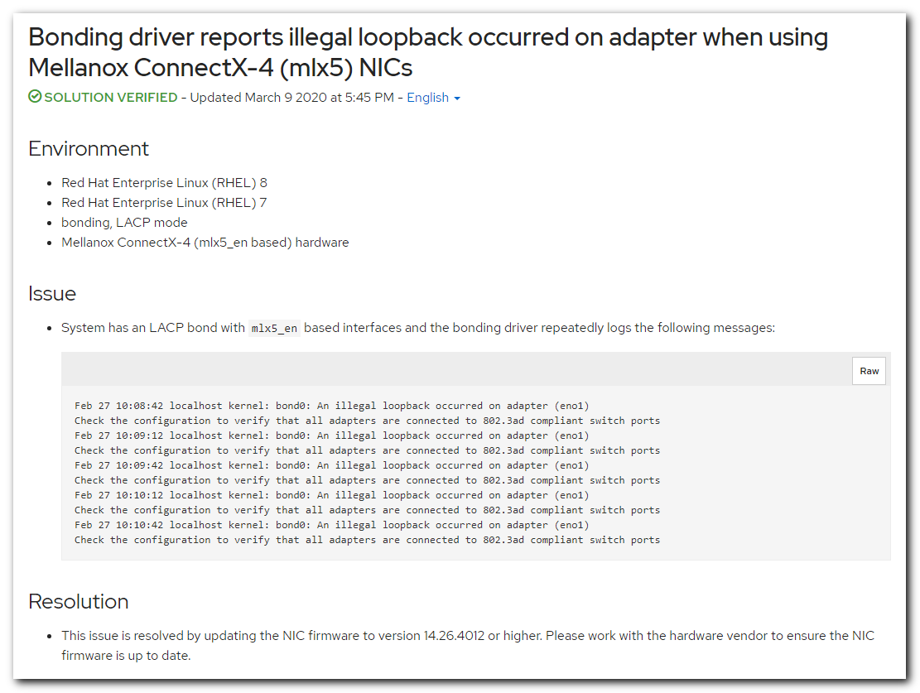
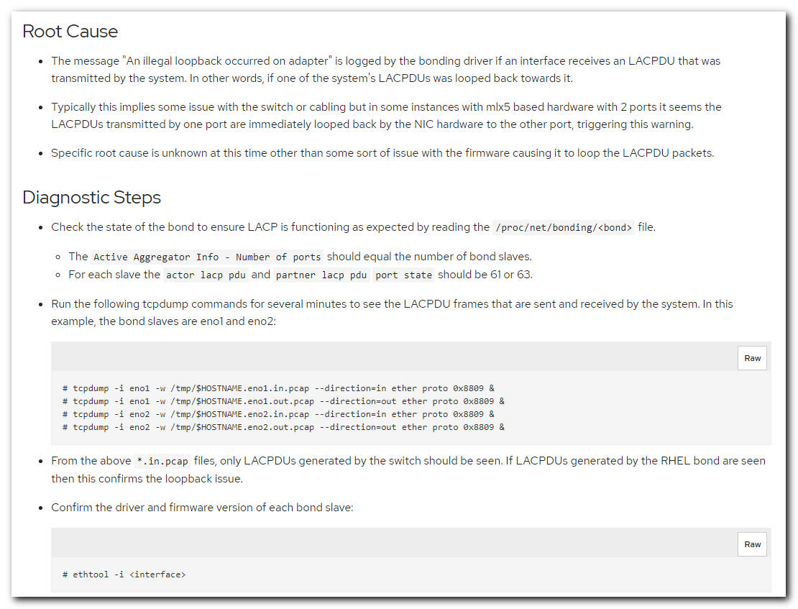
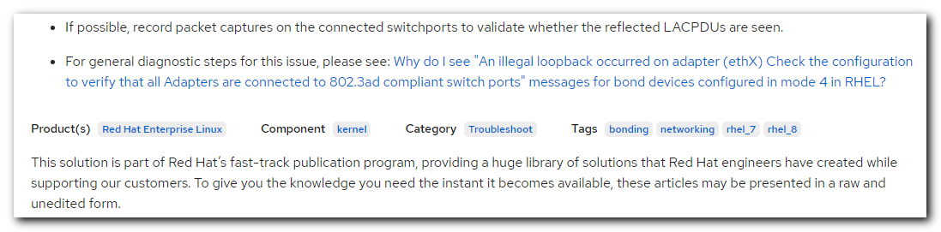

https://access.redhat.com/solutions/56604
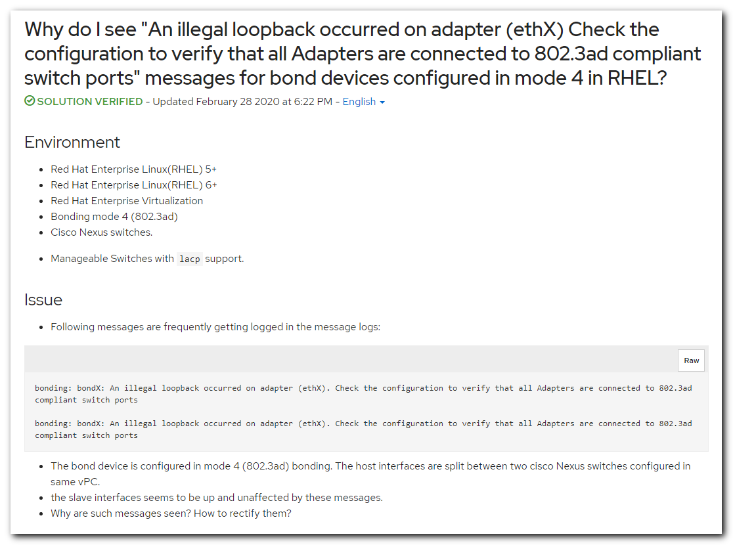
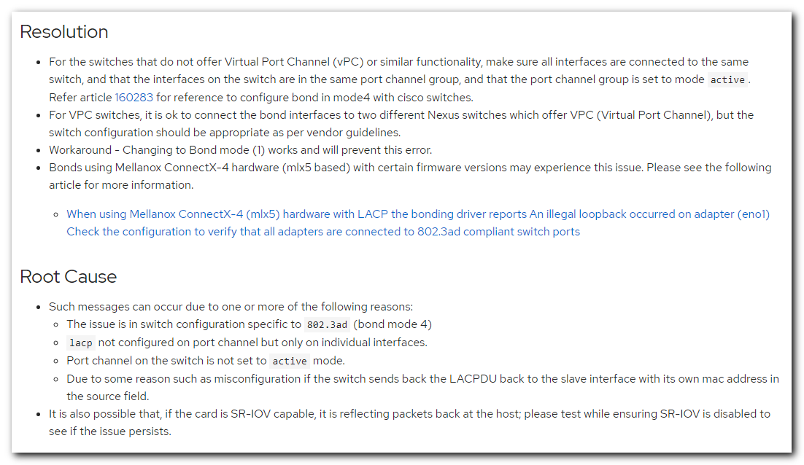
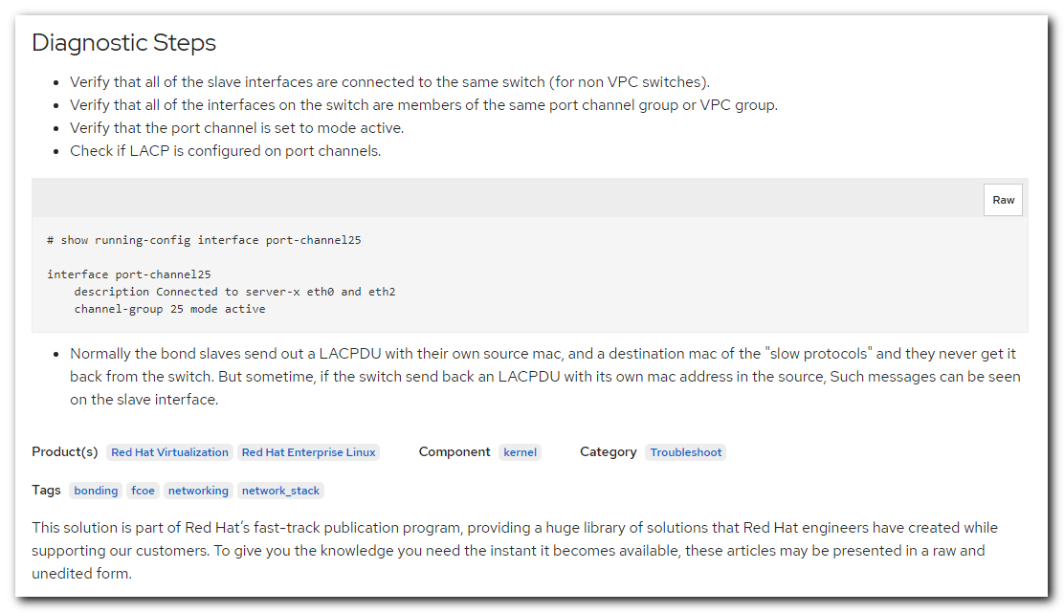

................................................................................
Белогруд Сергей Владимирович
• Сегодня 19:34
Нужно запланировать downtime сервера (потребуется его перезагрузка).
Для обновления firmware сетевой карты Mellanox.
................................................................................
https://downloads.linux.hpe.com/SDR/repo/spp-gen9/RHEL/7.8/x86_64/current/

https://downloads.linux.hpe.com/SDR/repo/spp-gen9/RHEL/7.8/x86_64/current/firmware-nic-mellanox-ethernet-only-1.0.10-1.1.x86_64.rpm
https://downloads.linux.hpe.com/SDR/repo/spp-gen9/RHEL/7.8/x86_64/current/firmware-nic-mellanox-ethernet-only-1.0.14-1.1.x86_64.rpm
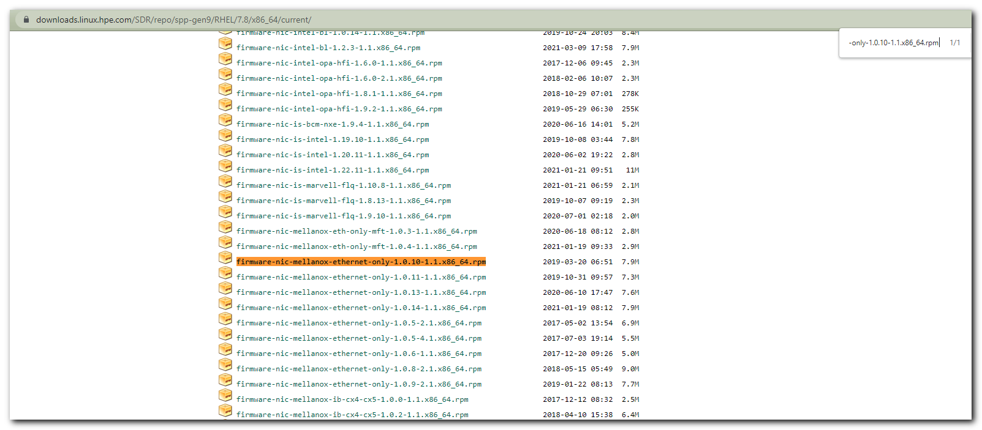
................................................................................
#
# 20210907
#
[s.belogrud@nb2339]# scp /drives/c/Users/s.belogrud/Downloads/firmware-nic-mellanox-ethernet-only-1.0.14-1.1.x86_64.rpm bsv@ds-pr-paym-es-w-metal-01:/tmp
firmware-nic-mellanox-ethernet-only-1.0.14-1.1.x86_64.rpm 100% 8133KB 3.9MB/s 00:02
[s.belogrud@nb2339]# scp /drives/c/Users/s.belogrud/Downloads/firmware-nic-mellanox-ethernet-only-1.0.10-1.1.x86_64.rpm bsv@ds-pr-paym-es-w-metal-01:/tmp

firmware-nic-mellanox-ethernet-only-1.0.10-1.1.x86_64.rpm 100% 8042KB 3.9MB/s 00:02
[s.belogrud@nb2339]#

[s.belogrud@nb2339]# ssh bsv@ds-pr-paym-es-w-metal-01
Last login: Mon Sep 6 19:08:23 2021 from 172.30.50.21
bsv@ds-pr-paym-es-w-metal-01 ~$ sudo -i
[sudo] password for bsv:
root@ds-pr-paym-es-w-metal-01 ~$ mkdir -p ~/work/20210907-1159
root@ds-pr-paym-es-w-metal-01 ~$ cp /tmp/firmware-nic-mellanox-ethernet-only-1.0.1*.rpm ~/work/20210907-1159/
root@ds-pr-paym-es-w-metal-01 ~$ cd ~/work/20210907-1159/
root@ds-pr-paym-es-w-metal-01 work/20210907-1159$

root@ds-pr-paym-es-w-metal-01 work/20210907-1159$ ethtool -i eno5 | grep -ie "firmware-version"
firmware-version: 14.26.1040 (HP_2690110034)
root@ds-pr-paym-es-w-metal-01 work/20210907-1159$ ethtool -i eno6 | grep -ie "firmware-version"
firmware-version: 14.26.1040 (HP_2690110034)
root@ds-pr-paym-es-w-metal-01 work/20210907-1159$

root@ds-pr-paym-es-w-metal-01 work/20210907-1159$ ll
total 16180
-rwx------ 1 root root 8235307 Sep 7 11:59 firmware-nic-mellanox-ethernet-only-1.0.10-1.1.x86_64.rpm
-rwx------ 1 root root 8328427 Sep 7 11:59 firmware-nic-mellanox-ethernet-only-1.0.14-1.1.x86_64.rpm
root@ds-pr-paym-es-w-metal-01 work/20210907-1159$

root@ds-pr-paym-es-w-metal-01 work/20210907-1159$ rpm -ivh ./firmware-nic-mellanox-ethernet-only-1.0.14-1.1.x86_64.rpm
warning: ./firmware-nic-mellanox-ethernet-only-1.0.14-1.1.x86_64.rpm: Header V3 RSA/SHA256 Signature, key ID 26c2b797: NOKEY
Preparing... ################################# [100%]
Updating / installing...
1:firmware-nic-mellanox-ethernet-on################################# [100%]
root@ds-pr-paym-es-w-metal-01 work/20210907-1159$

root@ds-pr-paym-es-w-metal-01 work/20210907-1159$ /usr/lib/x86_64-linux-gnu/firmware-nic-mellanox-ethernet-only-1.0.14-1.1/setup

##################################################################################################
HPE Mellanox InfiniBand Online Firmware Upgrade Utility for Linux
Copyright (c) 2011 Hewlett-Packard Enterprise Development Company, L.P.
##################################################################################################

SecureBoot is disabled.
List of Network Adapters detected on the Server.................
[0] 0000:02:00.0 Broadcom Inc. and subsidiaries
[1] 0000:5d:00.0 Mellanox Technologies

If PSID or FW_Version is not found for some interfaces, please check /tmp/dataGDdUPN

Interface 0000:02:00.0 is not Mellanox one.

Mellanox card info for 0000:5d:00.0 = FW_VERSION 14.26.1040, BUS_INFO 0000:5d:00.0, PSID HP_2690110034
0000:5d:00.0
DEVICE INFO---------->15b3 1015 1590 d3
pciIdString-------------->15B3-1015-1590-00D3-HP_2690110034

Repository has New firmware version for interface 0000:5d:00.0.................Please flash the newer version

Current Firmware Version is 14.26.1040 on 0000:5d:00.0
Repository has these firmware versions............[1] Image Version 14.29.1016
Would you like to flash the firmware?
y/n/q (y):y

Current FW version on flash: 14.26.1040
New FW version: 14.29.1016

Initializing image partition - OK
Writing Boot image component - 4%
...
Writing Boot image component - OK
-I- To load new FW run mstfwreset or reboot machine.
Firmware Flashed: SUCCESS for interface 0000:5d:00.0

Please Reboot node for new image to be loaded into silicon

root@ds-pr-paym-es-w-metal-01 work/20210907-1159$

root@ds-pr-paym-es-w-metal-01 work/20210907-1159$ shutdown -r now
Connection to ds-pr-paym-es-w-metal-01 closed by remote host.
Connection to ds-pr-paym-es-w-metal-01 closed.
[s.belogrud@nb2339]#

[s.belogrud@nb2339]# ssh bsv@ds-pr-paym-es-w-metal-01
Last login: Tue Sep 7 11:58:26 2021 from 172.30.46.87
bsv@ds-pr-paym-es-w-metal-01 ~$ sudo -i
[sudo] password for bsv:
root@ds-pr-paym-es-w-metal-01 ~$ (ethtool -i eno5 ; ethtool -i eno6) | grep -ie "firmware-version"
firmware-version: 14.29.1016 (HP_2690110034)
firmware-version: 14.29.1016 (HP_2690110034)
root@ds-pr-paym-es-w-metal-01 ~$

root@ds-pr-paym-es-w-metal-01 ~$ tail -f /var/log/messages
Sep 7 12:29:26 ds-pr-paym-es-w-metal-01 consul: 2021/09/07 12:29:26 [WARN] agent: Check "paym-es-w-tcp-9200-check" socket connection failed: dial tcp 10.213.90.1:9201: connect: connection refused
Sep 7 12:29:26 ds-pr-paym-es-w-metal-01 consul[2178]: agent: Check "paym-es-w-tcp-9200-check" socket connection failed: dial tcp 10.213.90.1:9201: connect: connection refused
Sep 7 12:29:41 ds-pr-paym-es-w-metal-01 consul: 2021/09/07 12:29:41 [WARN] agent: Check "paym-es-w-tcp-9200-check" socket connection failed: dial tcp 10.213.90.1:9201: connect: connection refused
Sep 7 12:29:41 ds-pr-paym-es-w-metal-01 consul[2178]: agent: Check "paym-es-w-tcp-9200-check" socket connection failed: dial tcp 10.213.90.1:9201: connect: connection refused
Sep 7 12:30:01 ds-pr-paym-es-w-metal-01 systemd: Created slice User Slice of root.
Sep 7 12:30:01 ds-pr-paym-es-w-metal-01 systemd: Started Session 3 of user root.
Sep 7 12:30:01 ds-pr-paym-es-w-metal-01 systemd: Removed slice User Slice of root.
Sep 7 12:31:01 ds-pr-paym-es-w-metal-01 systemd: Created slice User Slice of root.
Sep 7 12:31:01 ds-pr-paym-es-w-metal-01 systemd: Started Session 4 of user root.
Sep 7 12:31:01 ds-pr-paym-es-w-metal-01 systemd: Removed slice User Slice of root.

root@ds-pr-paym-es-w-metal-01 ~$

#
# Задачу по этой же теме по другим серверам "Проверить firmware сетевой карты на bare metal ЕЛК" (https://jira.tcsbank.ru/browse/IN-1465) набросило на Курбанова Константина.

Oct 13, 2021
# Та же задачка по очередному серверу.
# Задача "обновить прошивку на сервере" (https://jira.tcsbank.ru/browse/IN-1629) [Третьяков Артём].
# https://tinkoff.slack.com/archives/C482SKHJP/p1634020936192400

# Oct 18, 2021 Задача "обновить прошивку на сервере" (https://jira.tcsbank.ru/browse/IN-1657) [Третьяков Артём]
#
# Make Nagios downtime.
# And collect information about server via ansible playbook.
#

[s.belogrud@nb2339]# scp /drives/c/Users/s.belogrud/Downloads/firmware-nic-mellanox-ethernet-only-1.0.14-1.1.x86_64.rpm s_s.belogrud@ds-pr-paym-es-w-meta
l-02.tcsbank.ru:/tmp/
firmware-nic-mellanox-ethernet-only-1.0.14-1.1.x86_64.rpm 100% 8133KB 3.9MB/s 00:02
[s.belogrud@nb2339]#

root@ds-pr-paym-es-w-metal-02 ~$ mkdir -p ~/work/20211013-1121
root@ds-pr-paym-es-w-metal-02 ~$ cp /tmp/firmware-nic-mellanox-ethernet-only-1.0.14-1.1.x86_64.rpm ~/work/20211013-1121/
root@ds-pr-paym-es-w-metal-02 ~$ cat /proc/net/bonding/bond0 | grep -ie "interface"
Slave Interface: eno5
Slave Interface: eno6
root@ds-pr-paym-es-w-metal-02 ~$ (ethtool -i eno5 ; ethtool -i eno6) | grep -ie "firmware-version"
firmware-version: 14.26.1040 (HP_2690110034)
firmware-version: 14.26.1040 (HP_2690110034)
root@ds-pr-paym-es-w-metal-02 ~$

root@ds-pr-paym-es-w-metal-02 ~$ rpm -ivh ~/work/20211013-1121/firmware-nic-mellanox-ethernet-only-1.0.14-1.1.x86_64.rpm
warning: /root/work/20211013-1121/firmware-nic-mellanox-ethernet-only-1.0.14-1.1.x86_64.rpm: Header V3 RSA/SHA256 Signature, key ID 26c2b797: NOKEY
Preparing... ################################# [100%]
package firmware-nic-mellanox-ethernet-only-1.0.14-1.1.x86_64 is already installed
root@ds-pr-paym-es-w-metal-02 ~$

root@ds-pr-paym-es-w-metal-02 ~$ /usr/lib/x86_64-linux-gnu/firmware-nic-mellanox-ethernet-only-1.0.14-1.1/setup

##################################################################################################
HPE Mellanox InfiniBand Online Firmware Upgrade Utility for Linux
Copyright (c) 2011 Hewlett-Packard Enterprise Development Company, L.P.
##################################################################################################

SecureBoot is disabled.
List of Network Adapters detected on the Server.................
[0] 0000:02:00.0 Broadcom Inc. and subsidiaries
[1] 0000:5d:00.0 Mellanox Technologies

If PSID or FW_Version is not found for some interfaces, please check /tmp/datalDHG2B

Interface 0000:02:00.0 is not Mellanox one.

Mellanox card info for 0000:5d:00.0 = FW_VERSION 14.26.1040, BUS_INFO 0000:5d:00.0, PSID HP_2690110034
0000:5d:00.0
DEVICE INFO---------->15b3 1015 1590 d3
pciIdString-------------->15B3-1015-1590-00D3-HP_2690110034

Repository has New firmware version for interface 0000:5d:00.0.................Please flash the newer version

Current Firmware Version is 14.26.1040 on 0000:5d:00.0
Repository has these firmware versions............[1] Image Version 14.29.1016
Would you like to flash the firmware?
y/n/q (y):y

Current FW version on flash: 14.26.1040
New FW version: 14.29.1016

Initializing image partition - OK
Writing Boot image component - 11%

...

Initializing image partition - OK
Writing Boot image component - OK
-I- To load new FW run mstfwreset or reboot machine.
Firmware Flashed: SUCCESS for interface 0000:5d:00.0

Please Reboot node for new image to be loaded into silicon

root@ds-pr-paym-es-w-metal-02 ~$

root@ds-pr-paym-es-w-metal-02 ~$ shutdown -r now
Connection to ds-pr-paym-es-w-metal-02.tcsbank.ru closed by remote host.
Connection to ds-pr-paym-es-w-metal-02.tcsbank.ru closed.
[s.belogrud@nb2339]#
[s.belogrud@nb2339]# ssh s_s.belogrud@ds-pr-paym-es-w-metal-02.tcsbank.ru
Last login: Wed Oct 13 11:20:26 2021 from 172.30.8.114
s_s.belogrud@ds-pr-paym-es-w-metal-02 ~$ sudo -i
[sudo] password for s_s.belogrud:
root@ds-pr-paym-es-w-metal-02 ~$ (ethtool -i eno5 ; ethtool -i eno6) | grep -ie "firmware-version"
firmware-version: 14.29.1016 (HP_2690110034)
firmware-version: 14.29.1016 (HP_2690110034)
root@ds-pr-paym-es-w-metal-02 ~$

